**Scenario Template**: Launch BestBuy Website, Select a Country and Validate URL is valid

**Scenario Template**: Create Account with No Test Data and Invalid Data

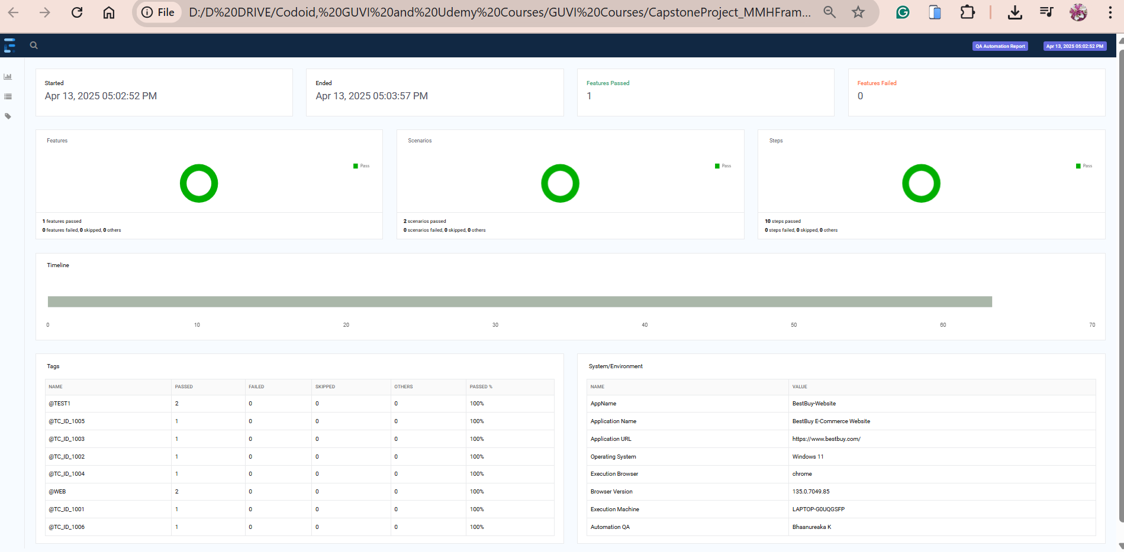

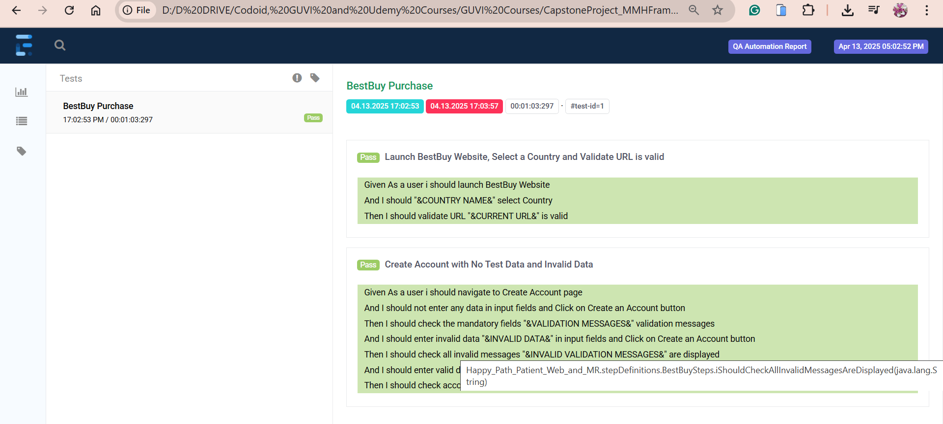

**Scenario Template: Login with Existing User**

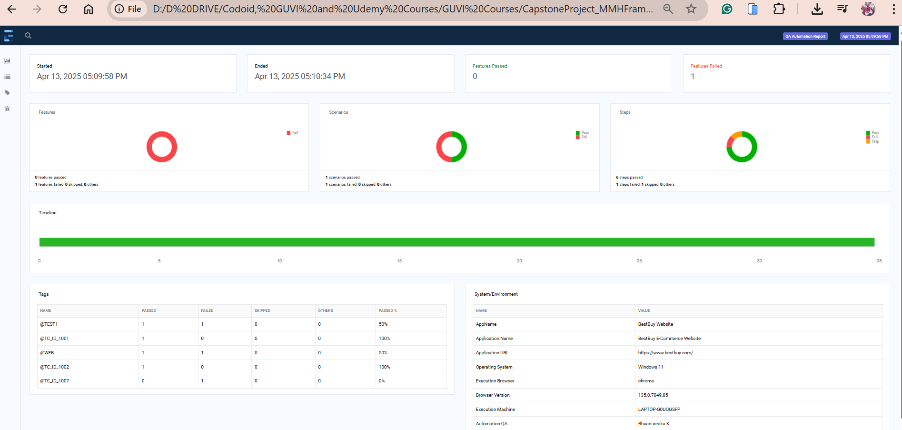

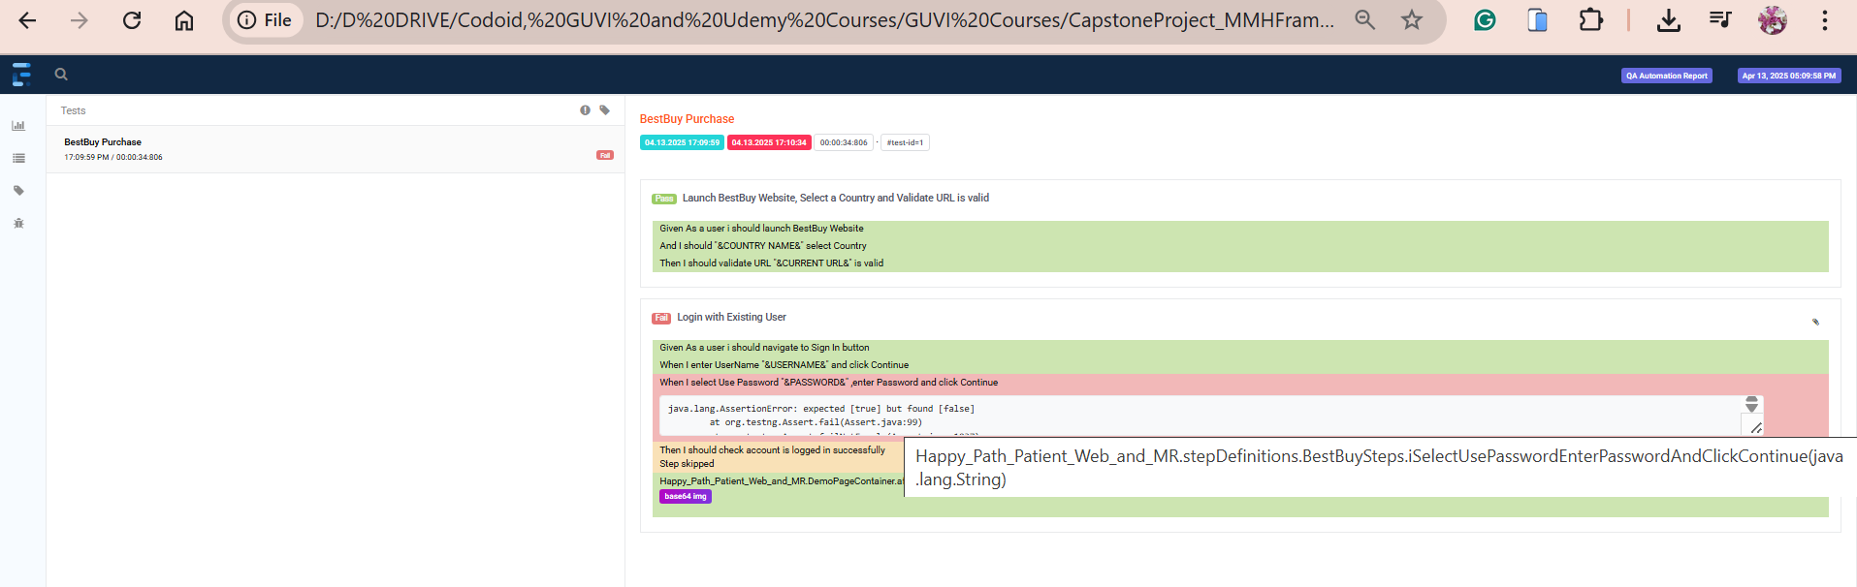

**Scenario Outline**: Navigate to Deals Menu , Deals and Deals by Category Sub-Menu and its Pages and Validate URL

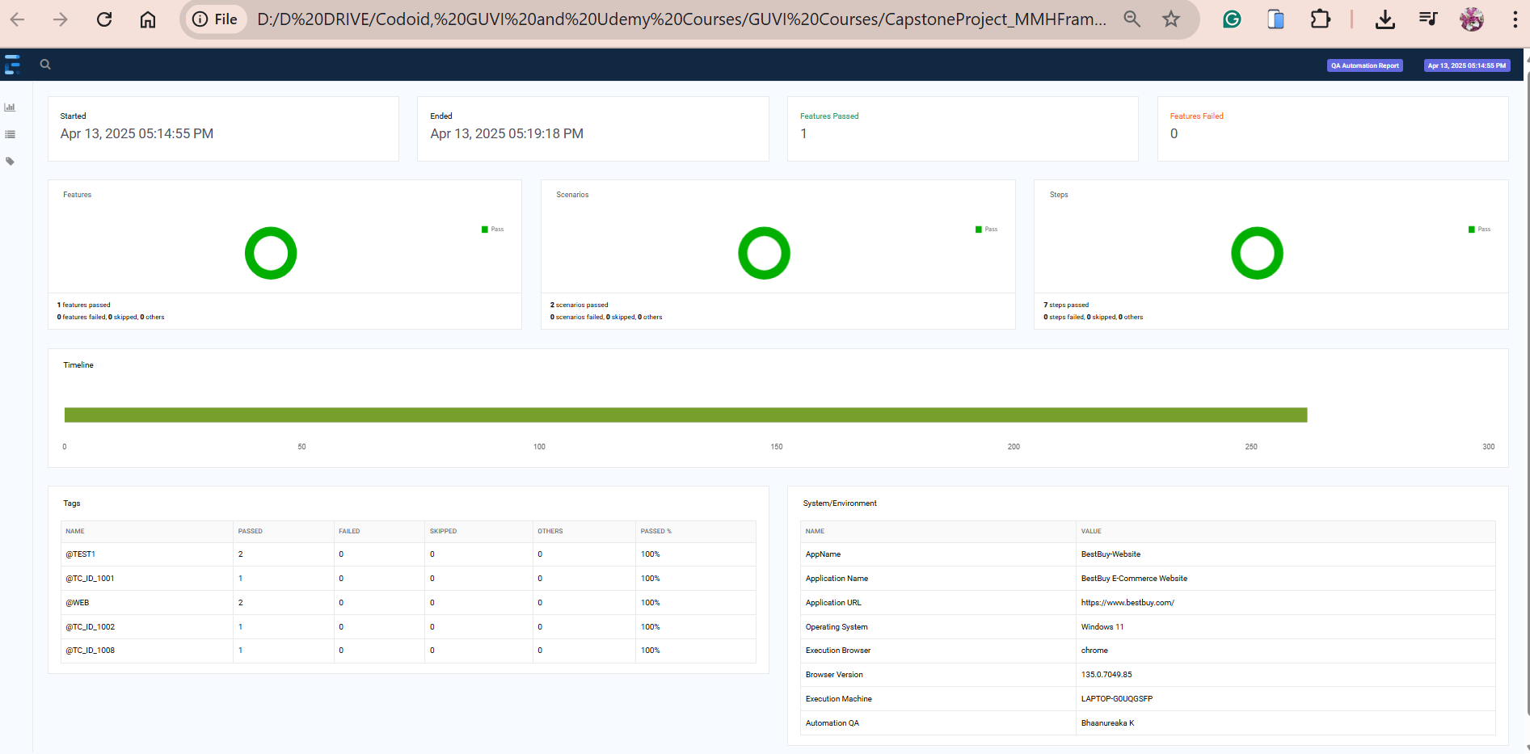

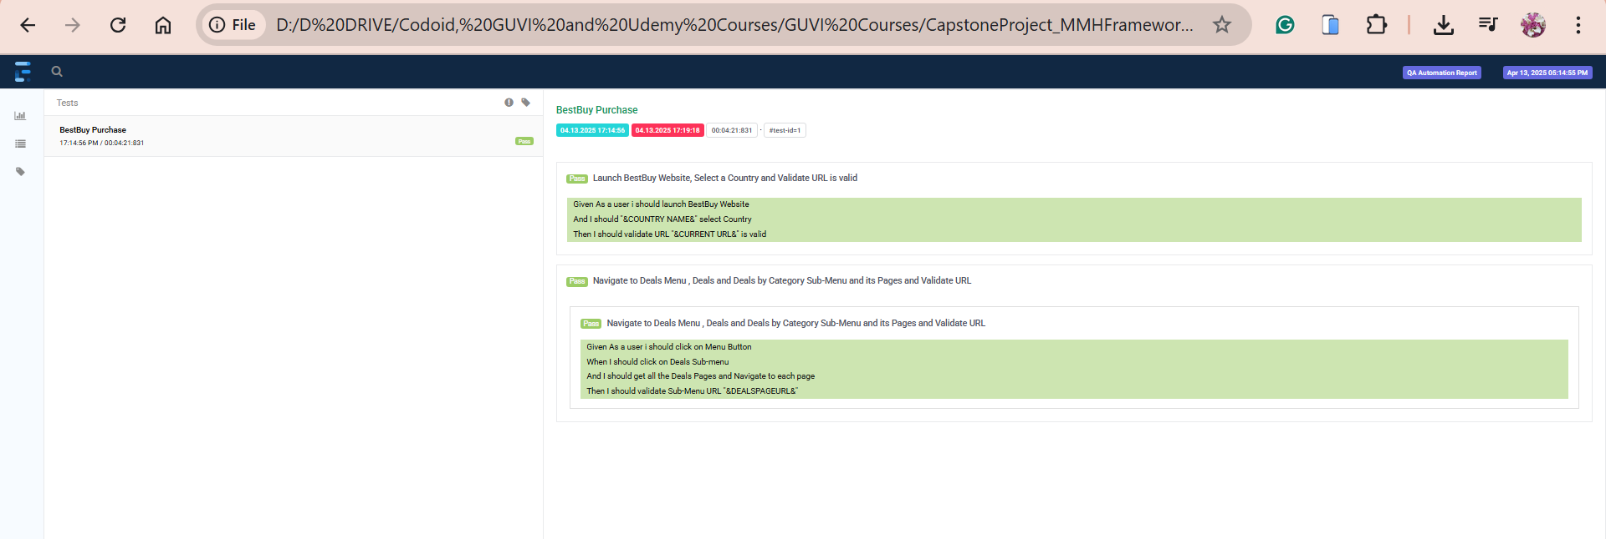

**Scenario Outline: Navigate to Deals Menu , Support and Services Sub-Menu and its Pages and Validate URL**

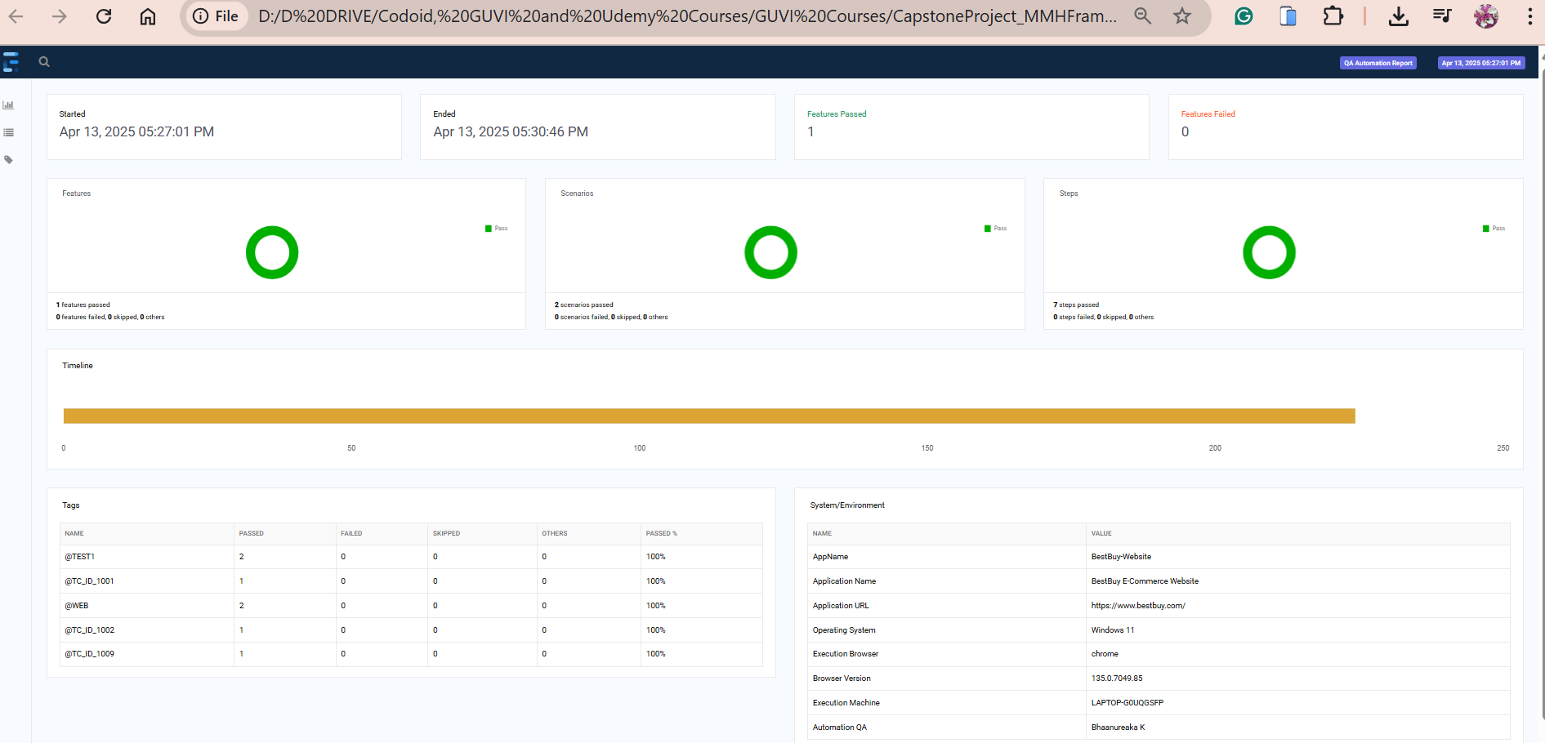

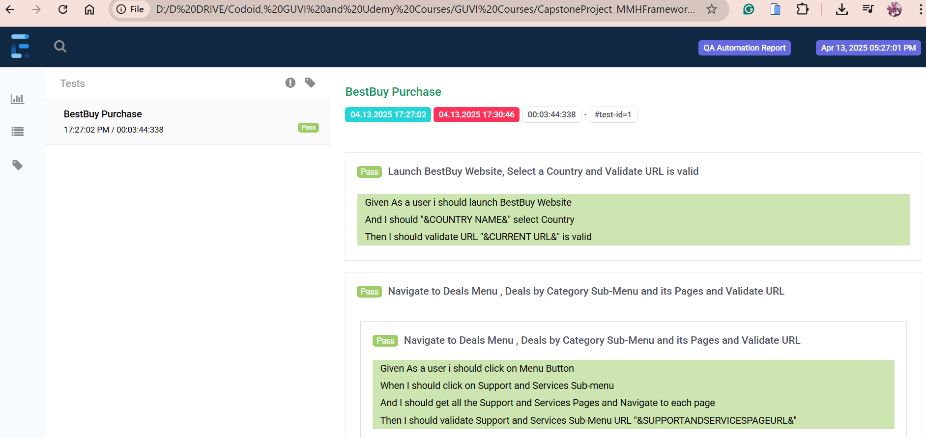

**Scenario Outline**: Navigate to Deals Menu , Brands Sub-Menu and its Pages and Validate URL

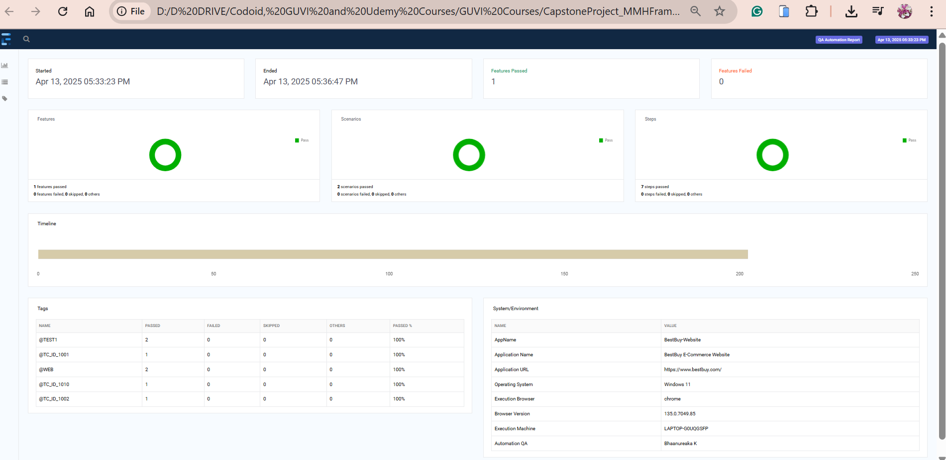

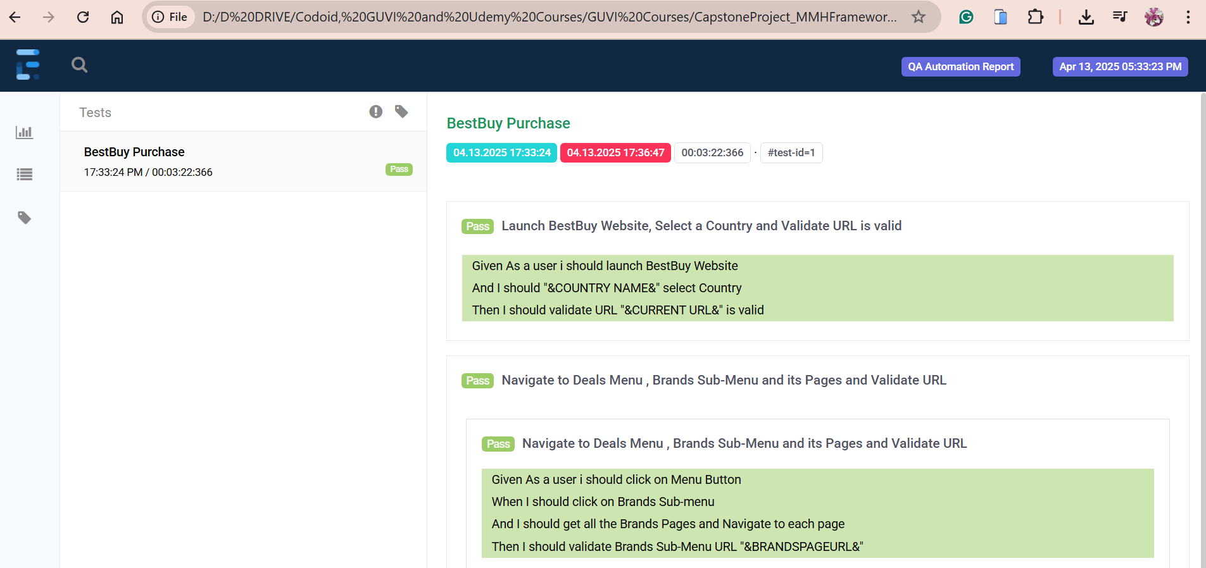

**Scenario Outline**: Navigate to Appliances Menu and Validate Menu

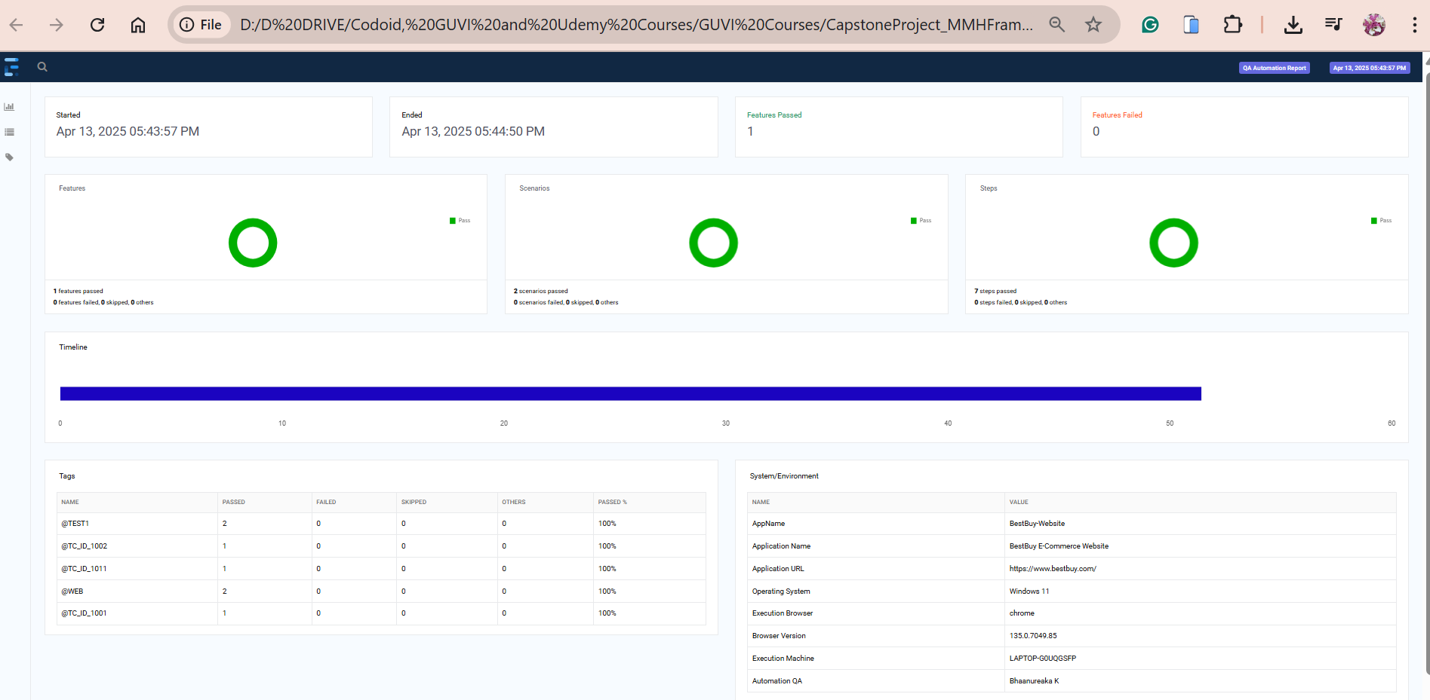

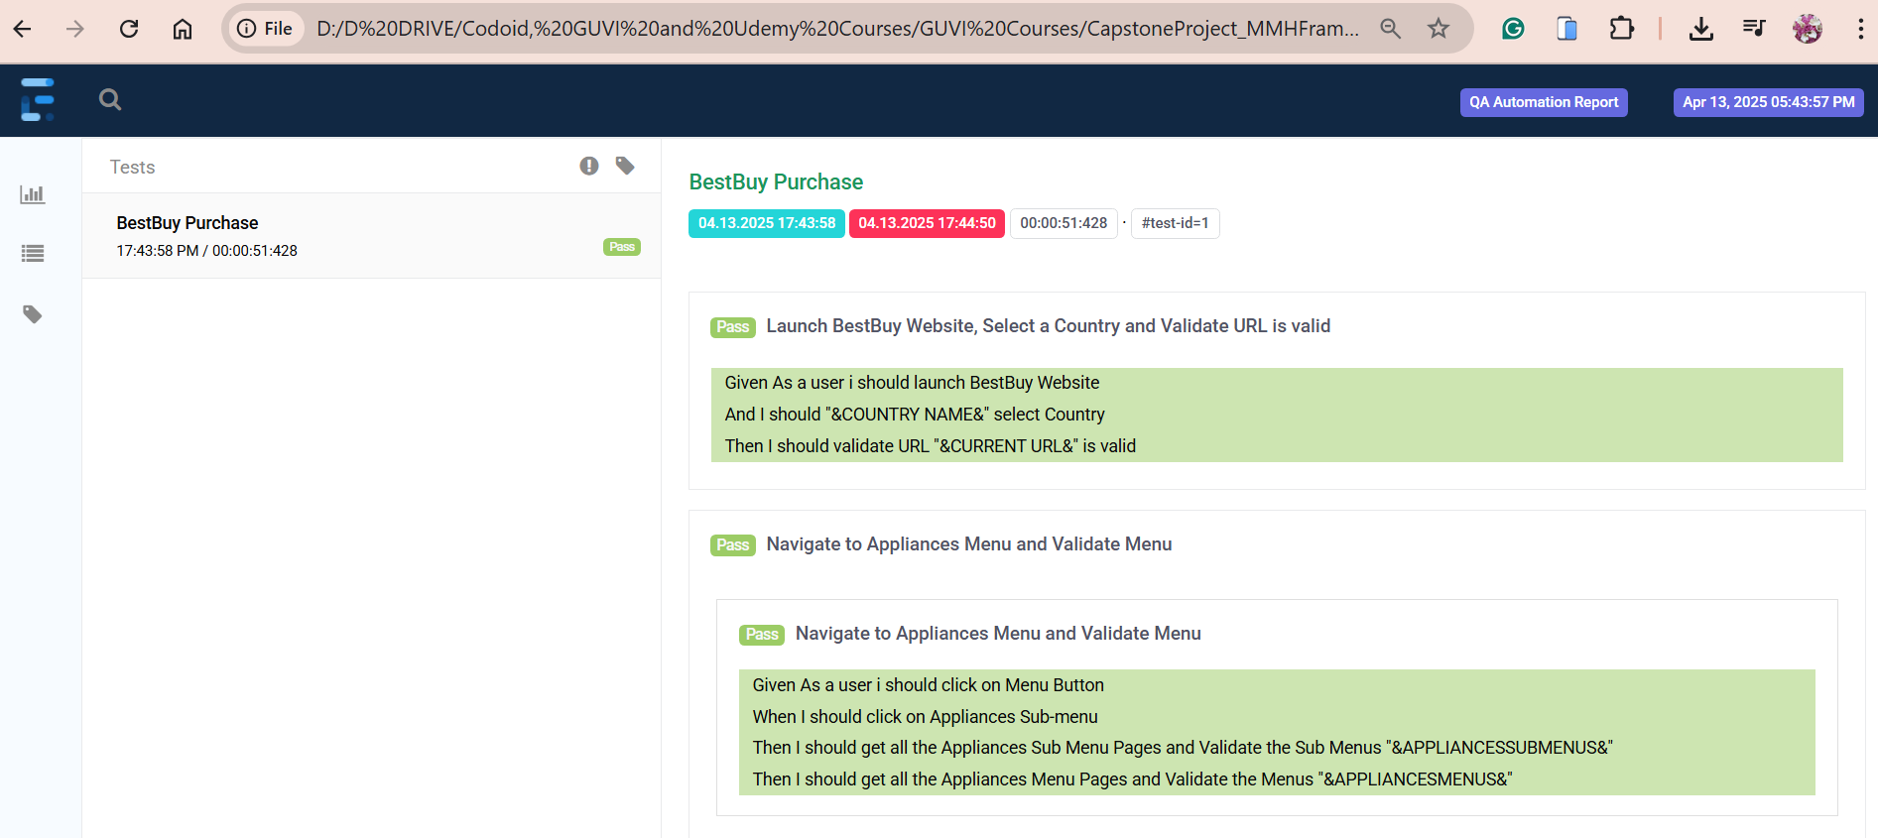

**Scenario Outline**: Navigate to TV & Home Theatre Menu and Validate Menu

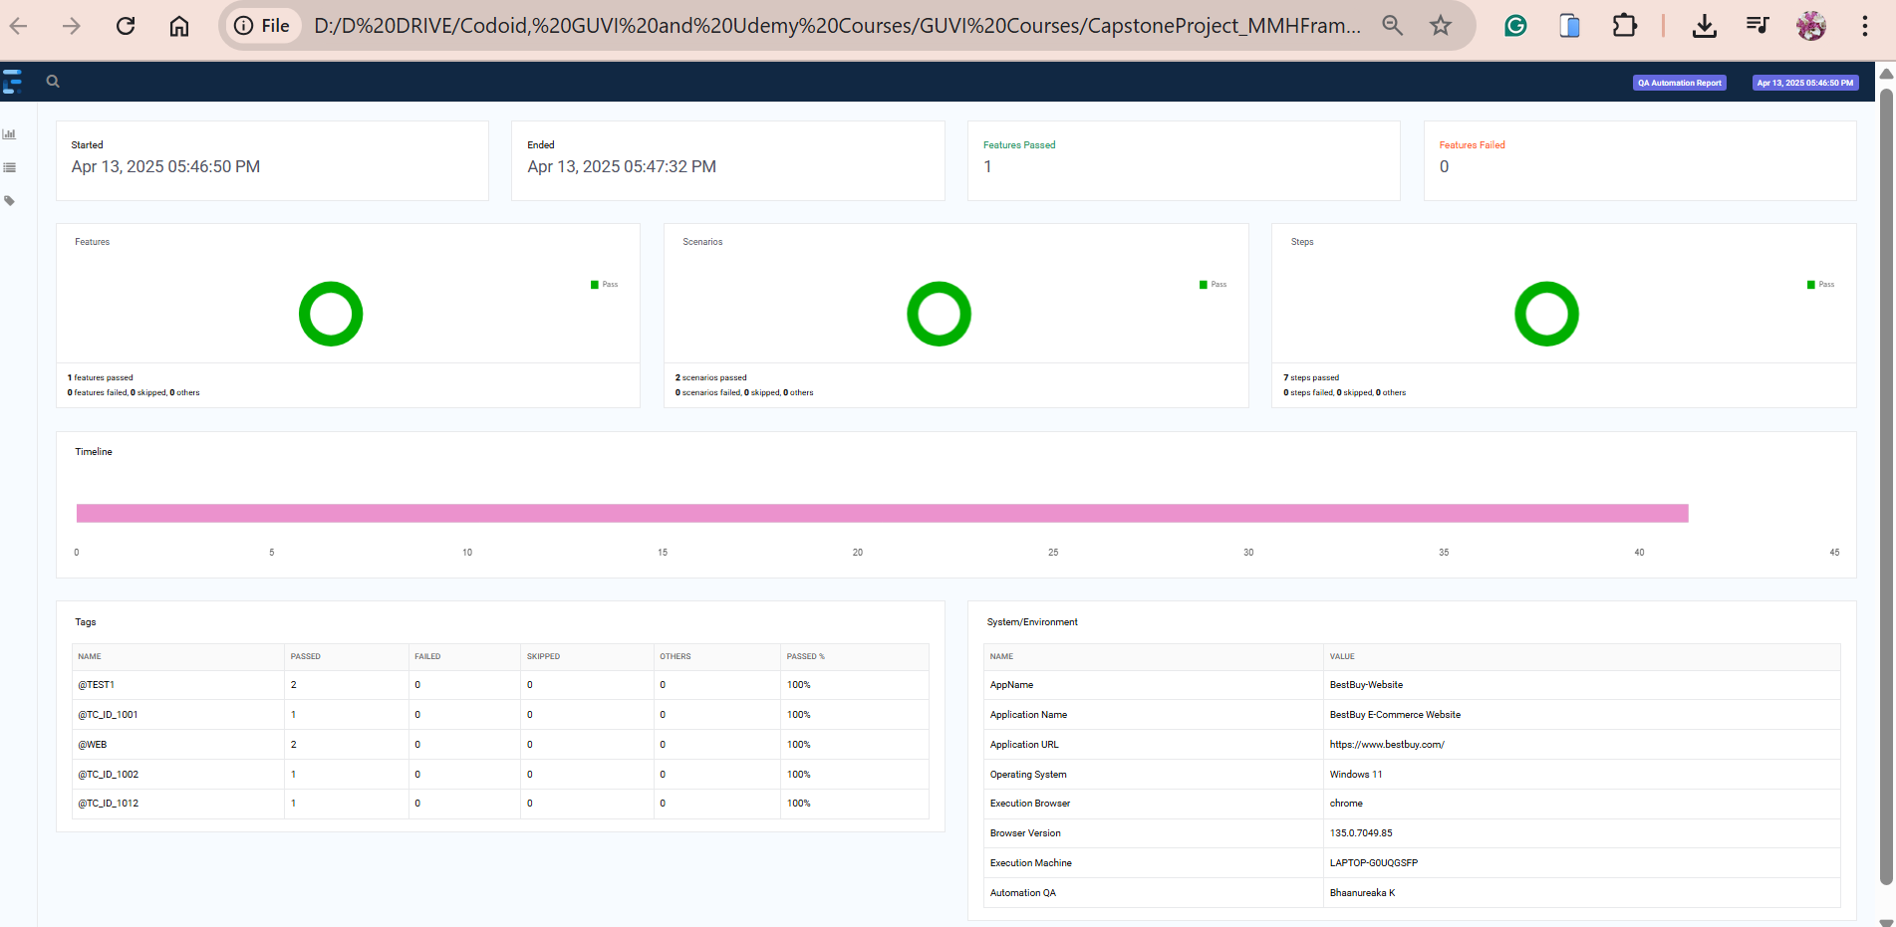

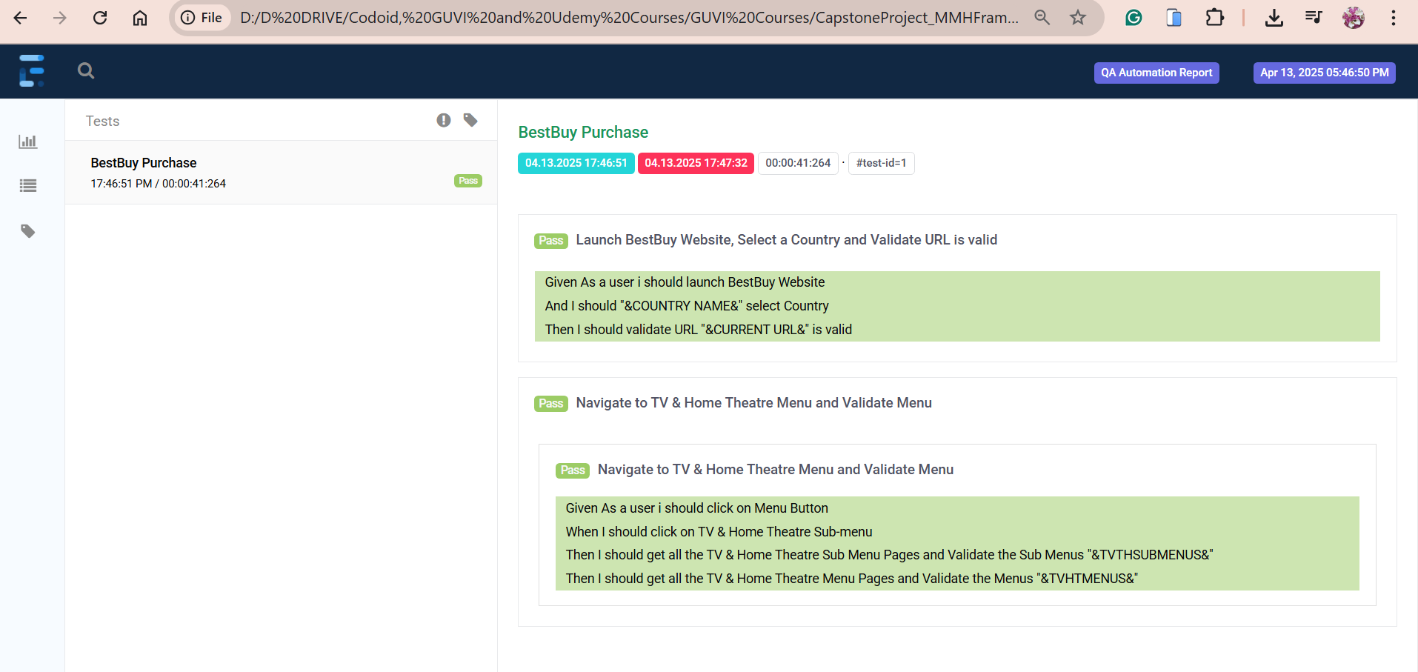

**Scenario Outline**: Navigate to Computers & Tablets Menu and Validate Menu

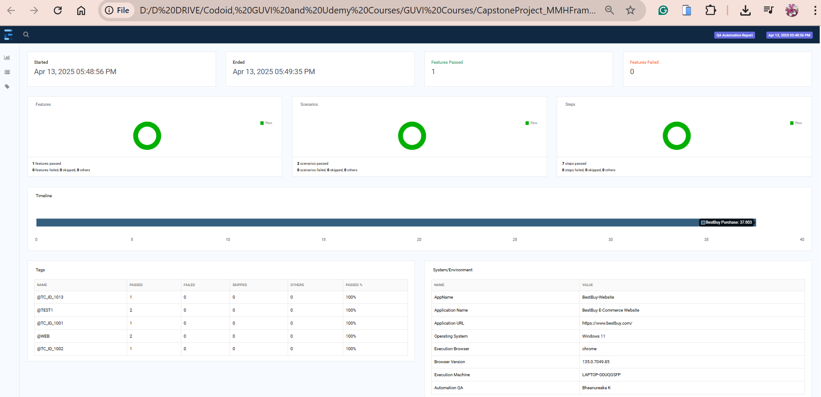

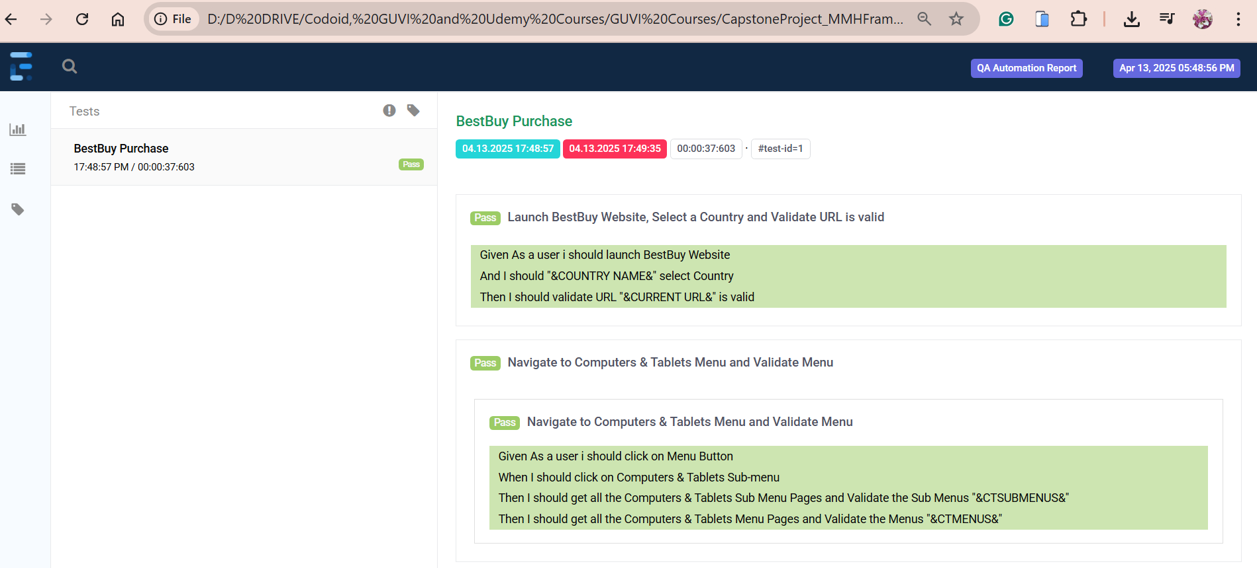

**Scenario Outline**: Navigate to Cell Phones Menu and Validate Menu

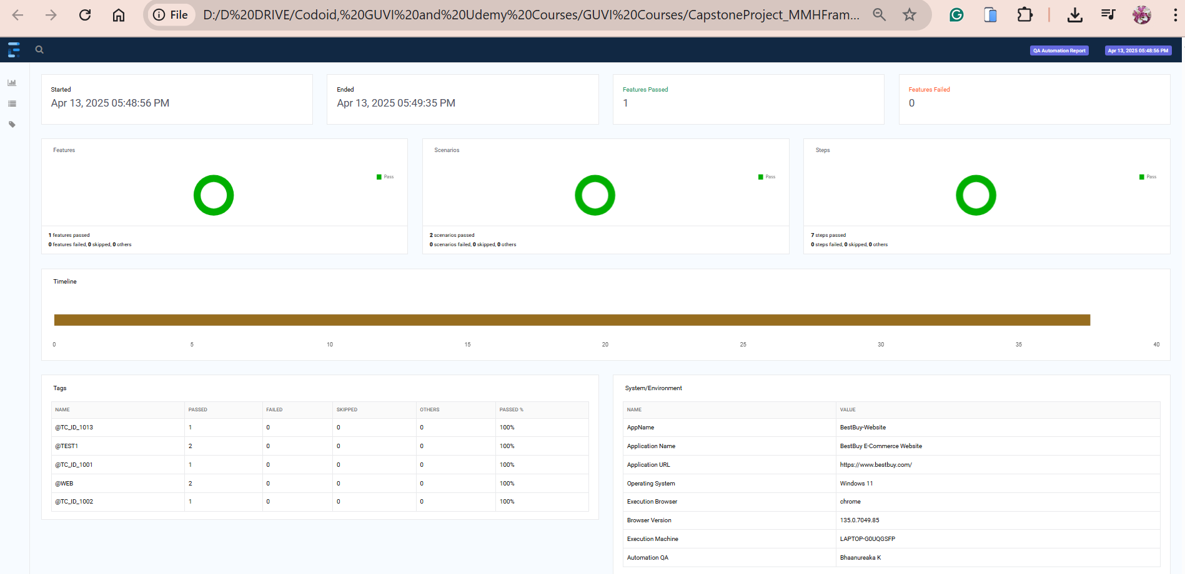

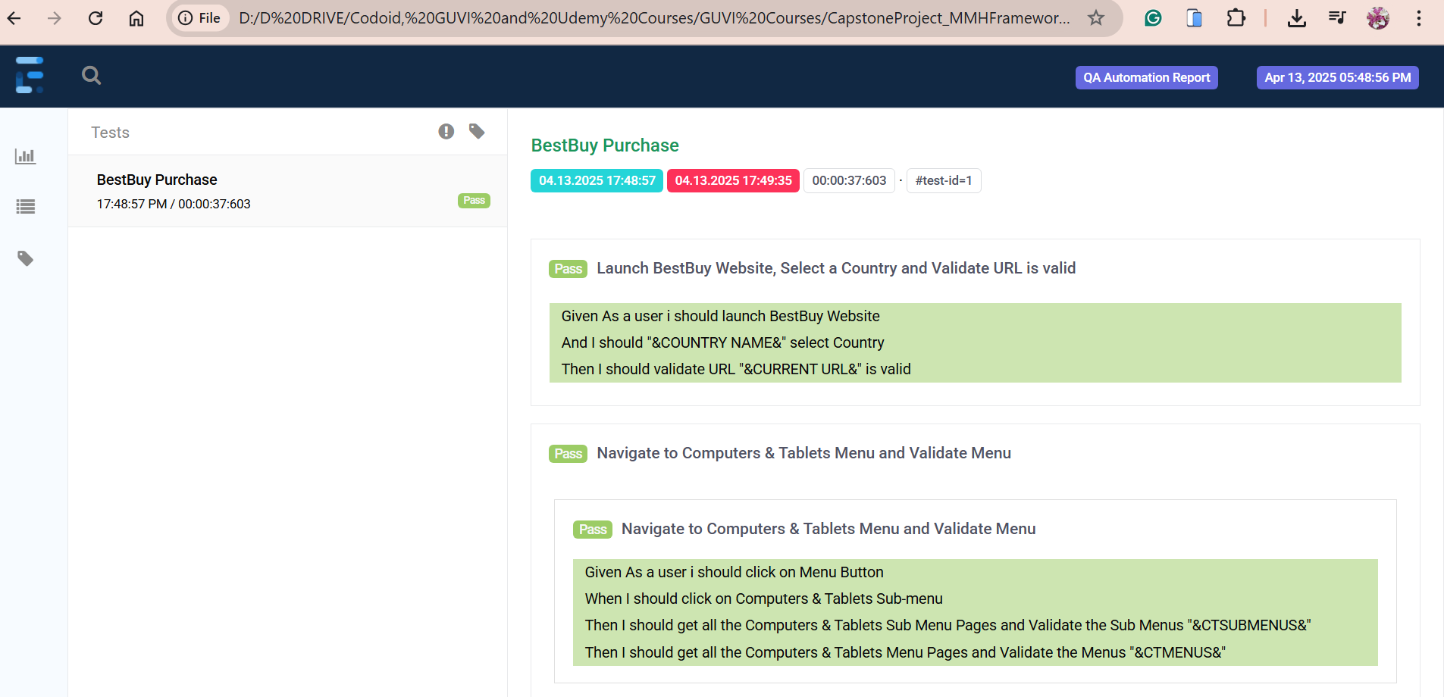

**Scenario Outline**: Navigate to Audio and Head Phones Menu and Validate Menu

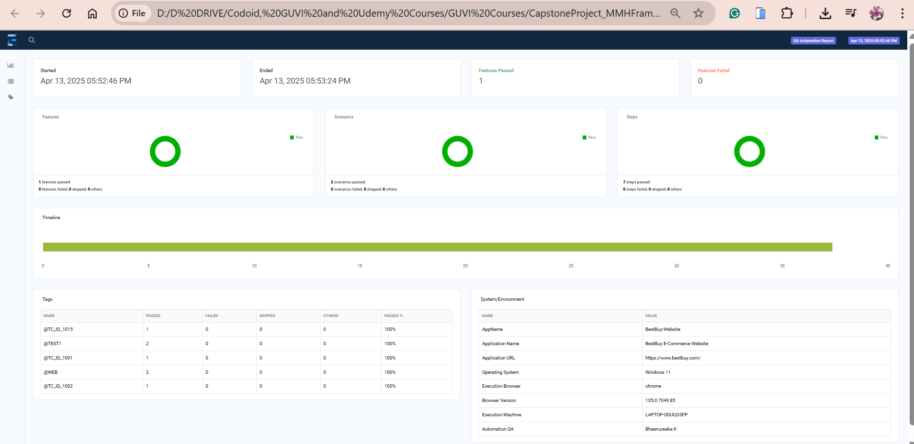

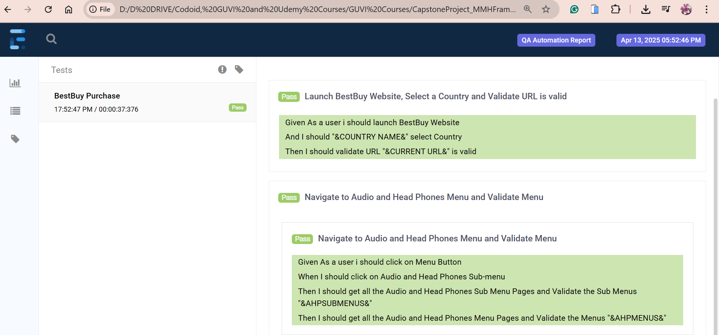

**Scenario Outline**: Navigate to Video Games Menu and Validate Menu

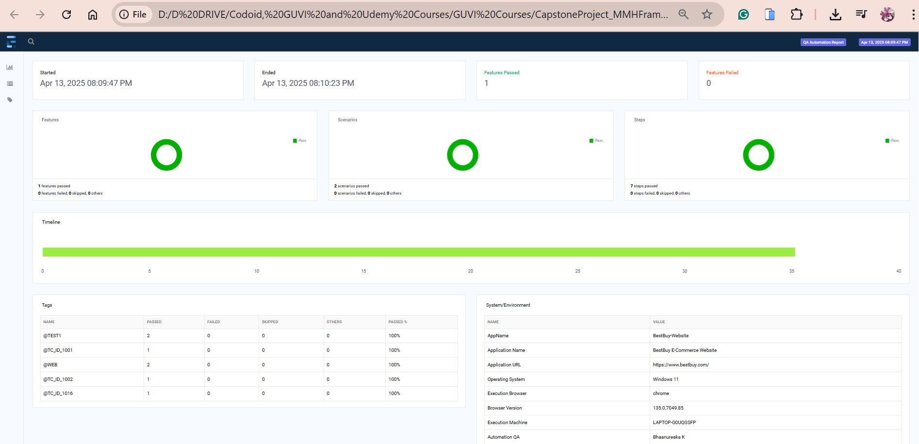

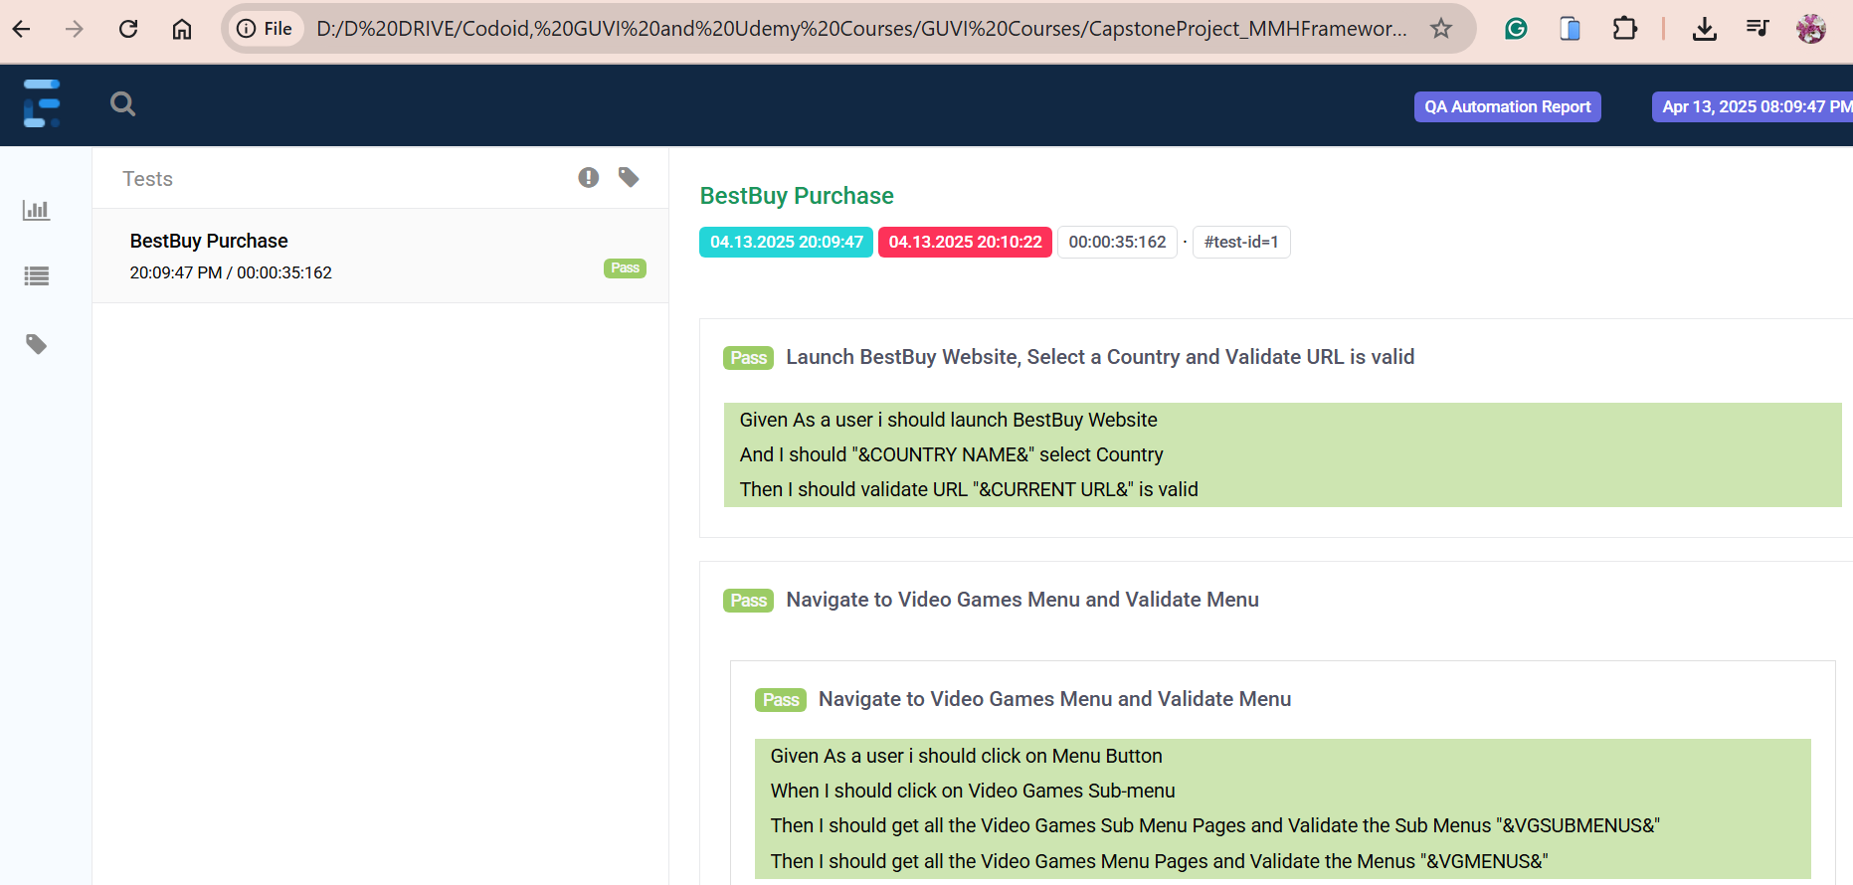

**Scenario Outline**: Navigate to Cameras,Cam recorders and Drones and Validate Menu

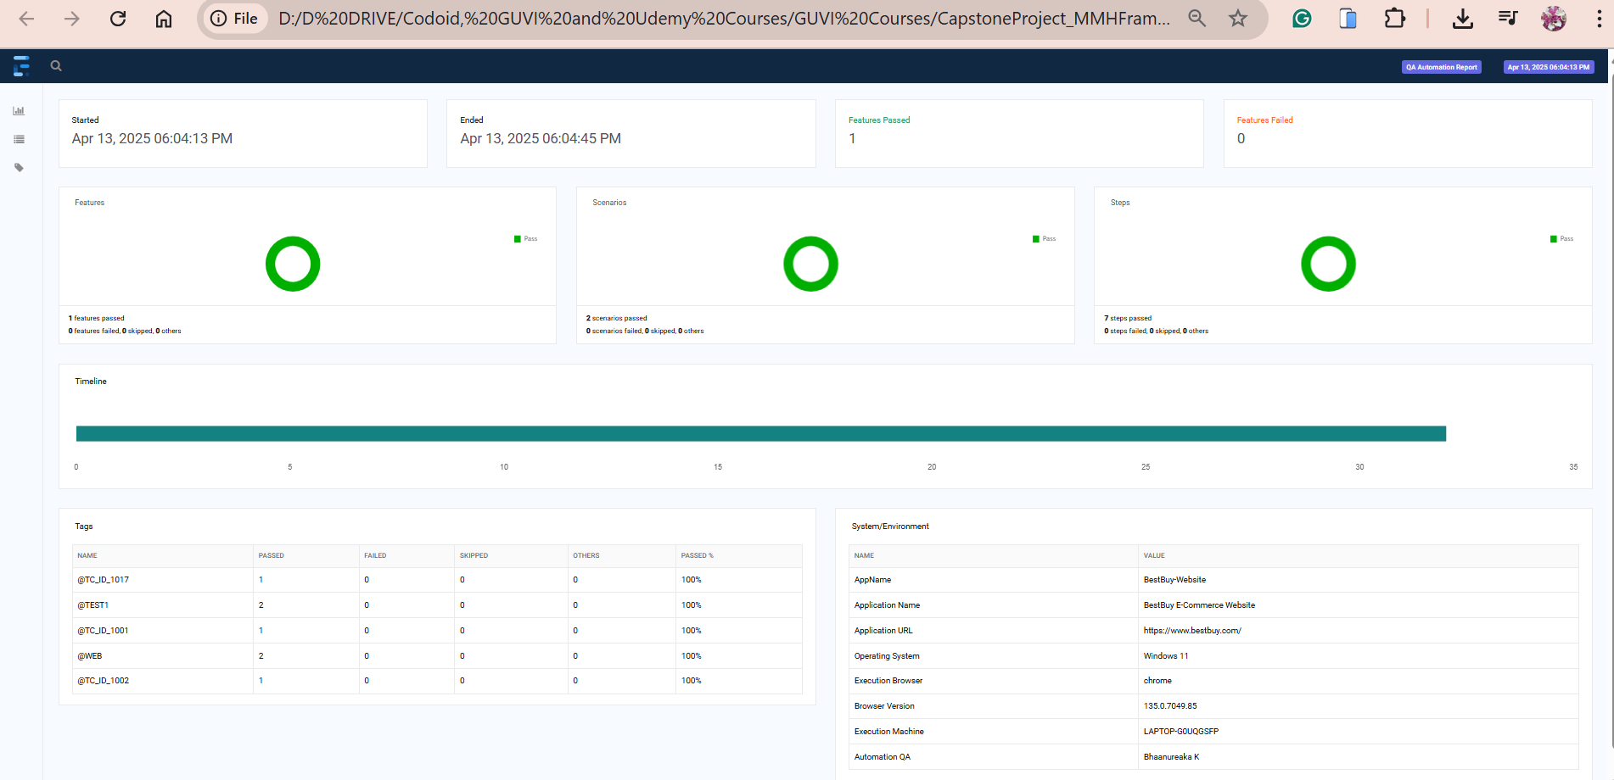

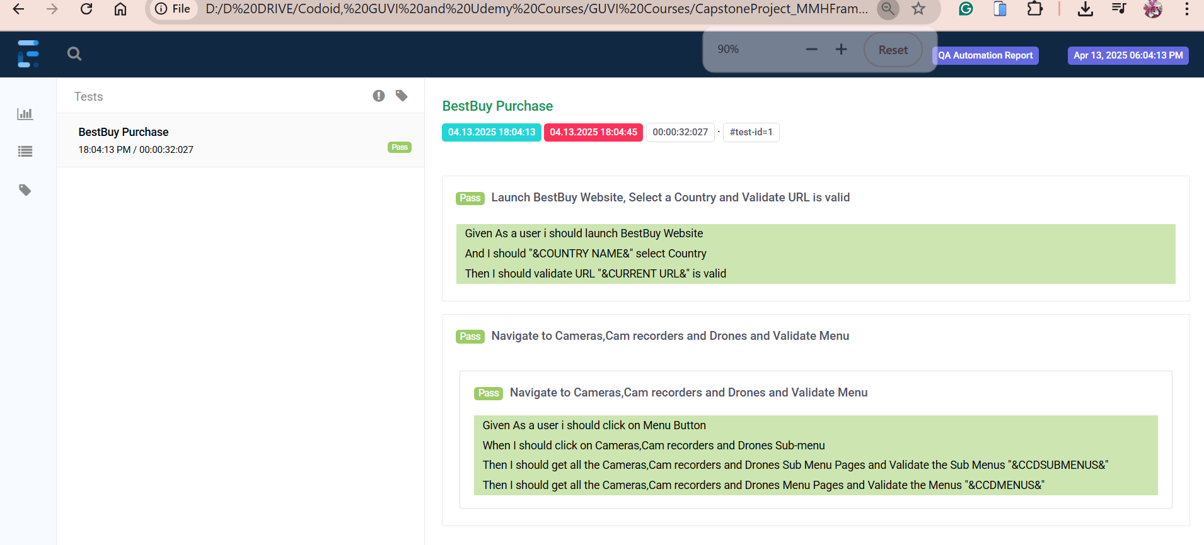

**Scenario Outline**: Navigate to Home,Furniture and Office and Validate Menu

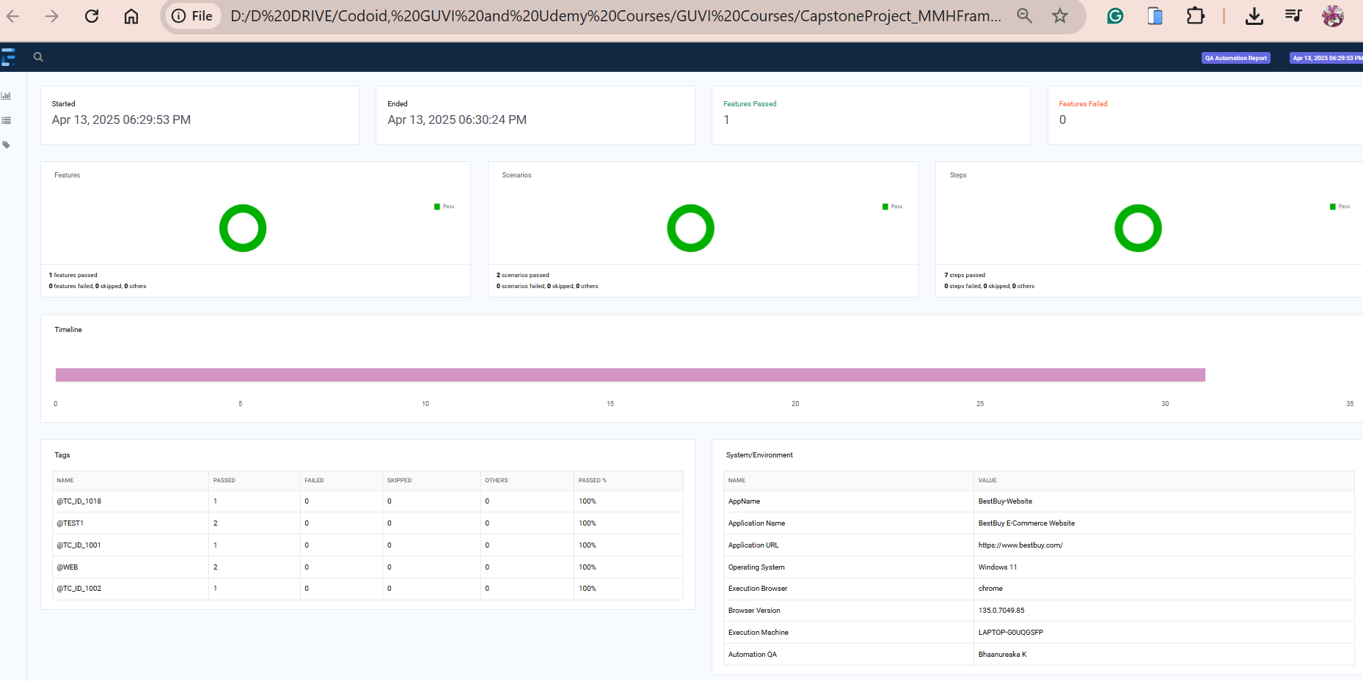

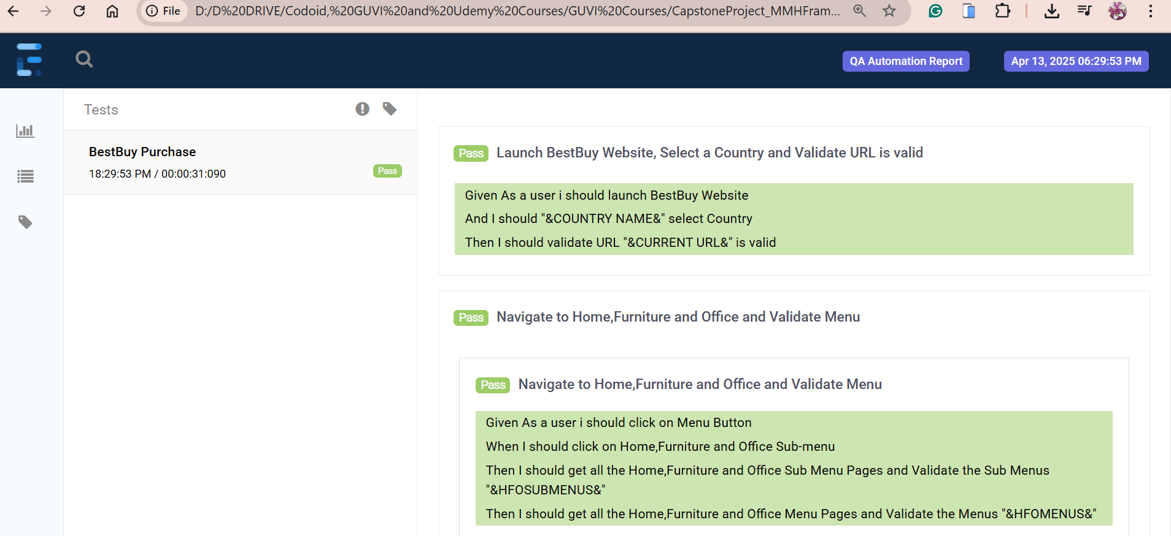

**Scenario Outline**: Navigate to Smart Home, Security & Wi-Fi and Validate Menu

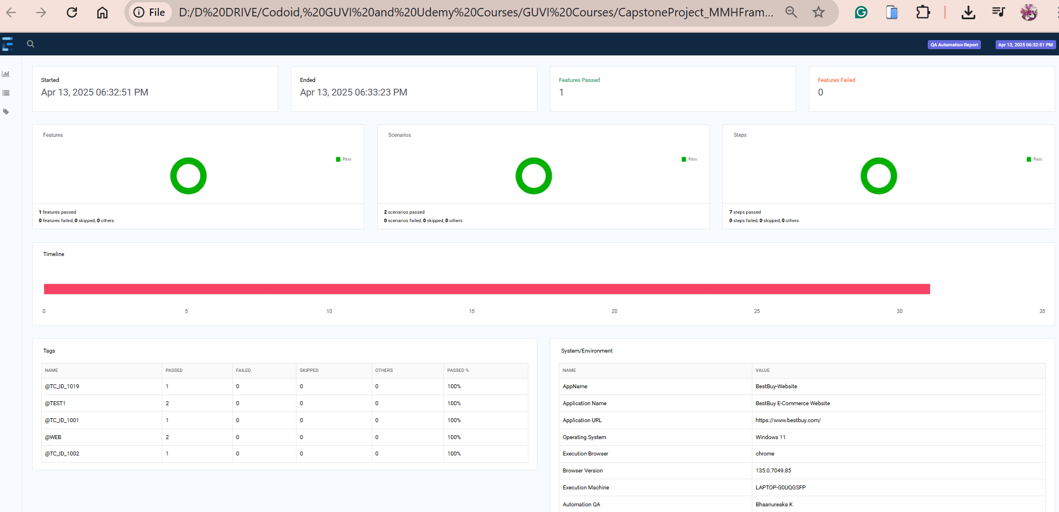

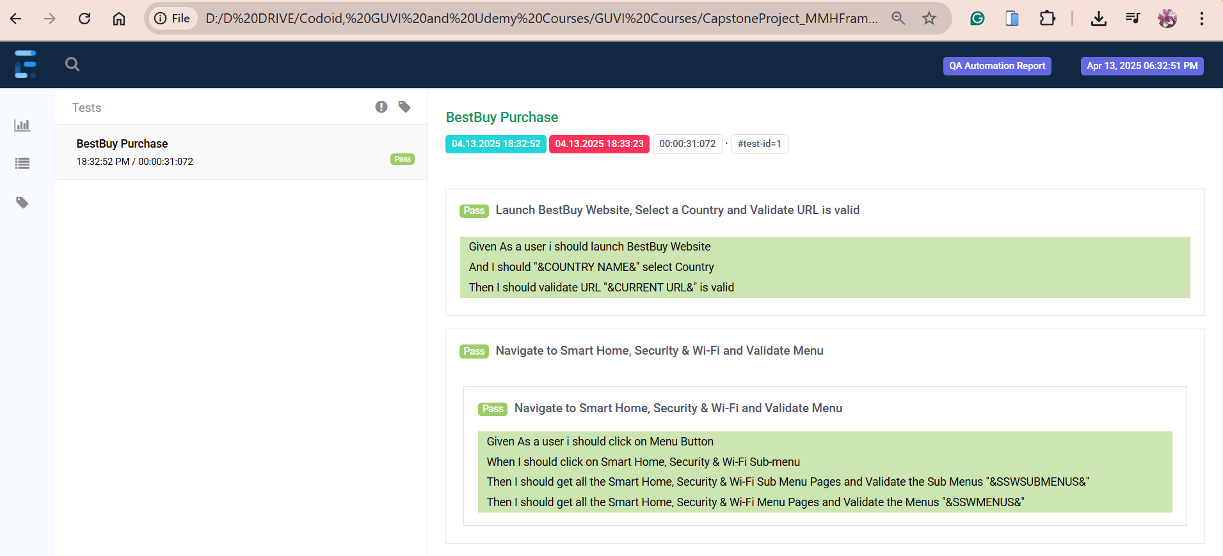

**Scenario Outline**: Navigate to Car Electronics & GPS and Validate Menu

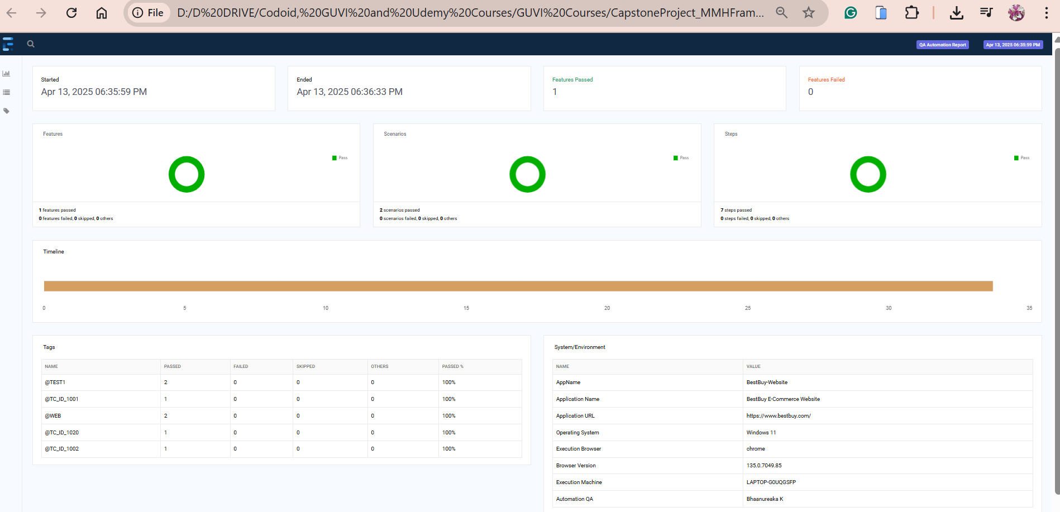

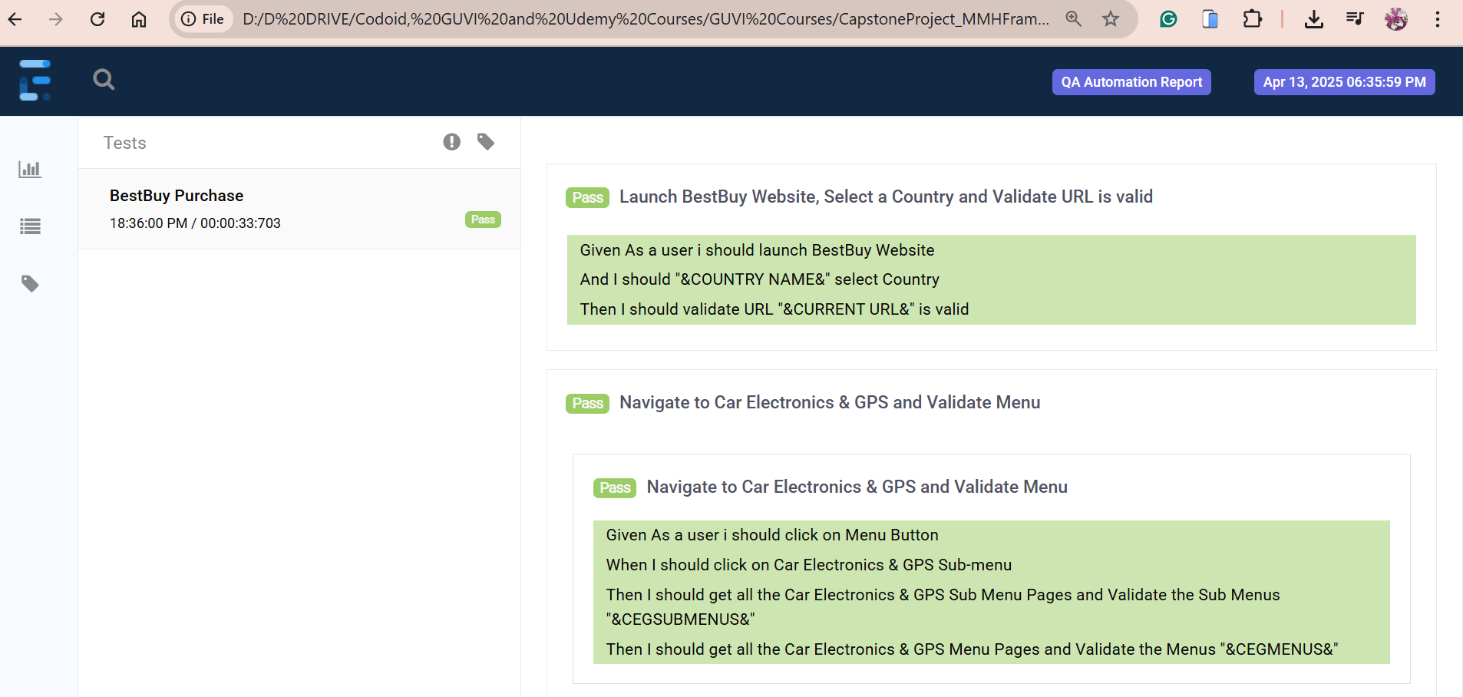

**Scenario Outline**: Navigate to Wearable Technology and Validate Menu

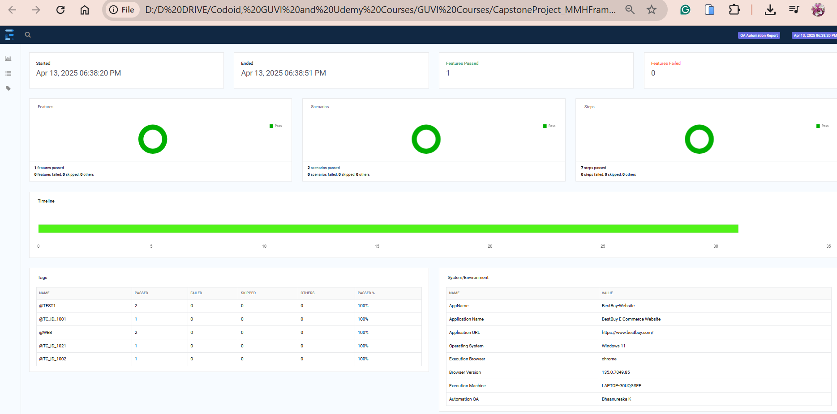

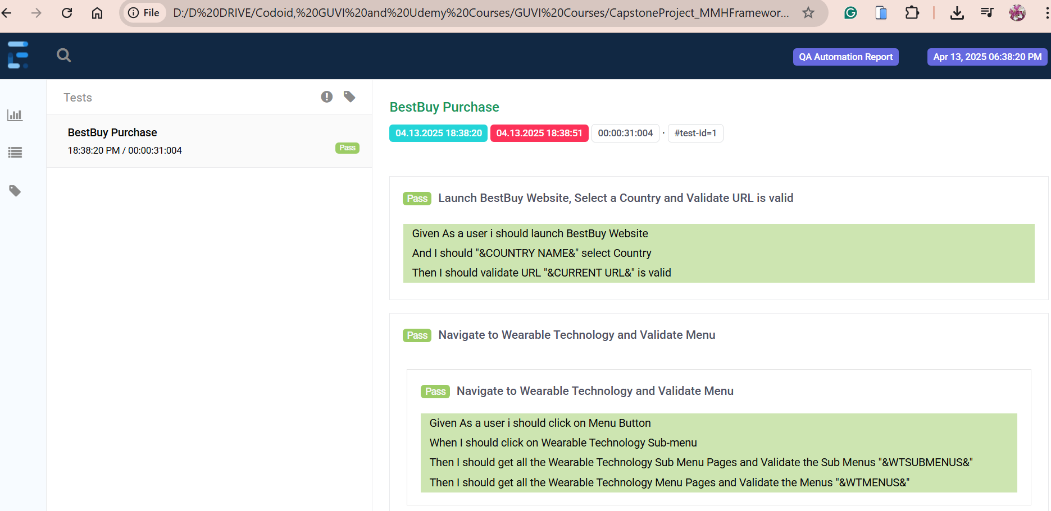

**Scenario Outline**: Navigate to Health, Wellness & Fitness and Validate Menu

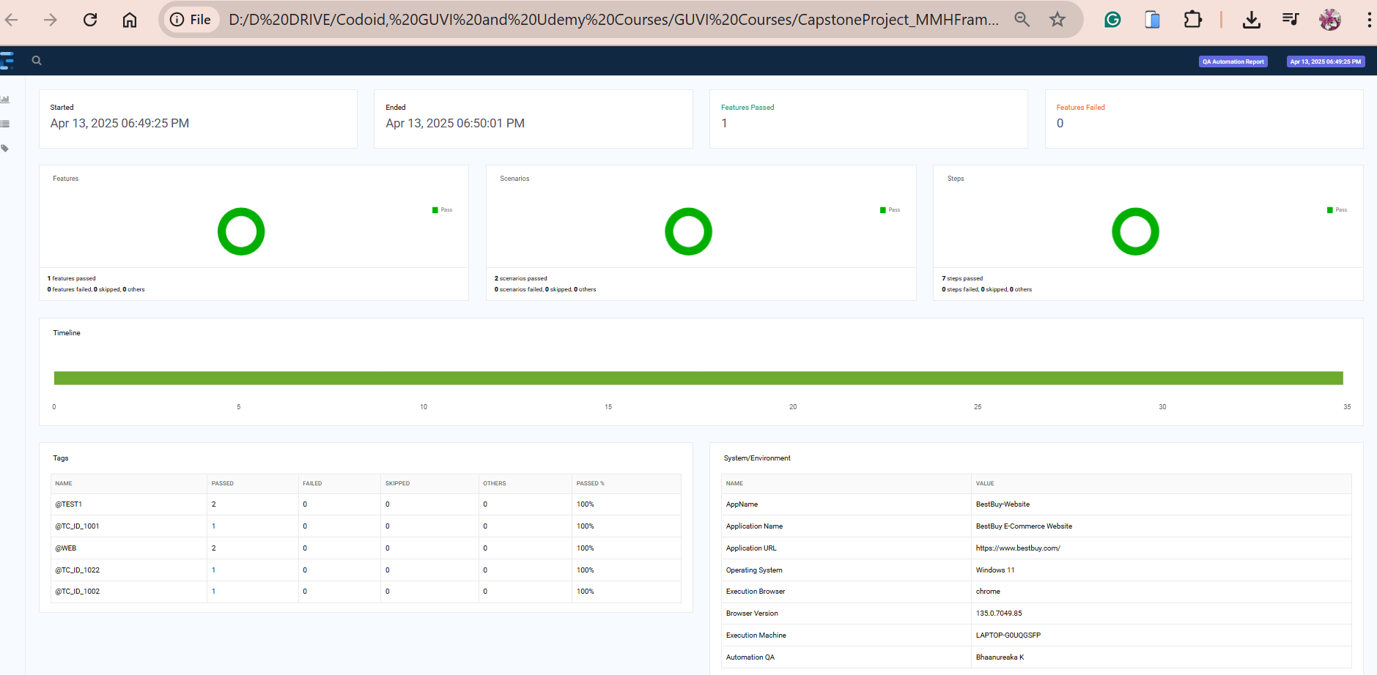

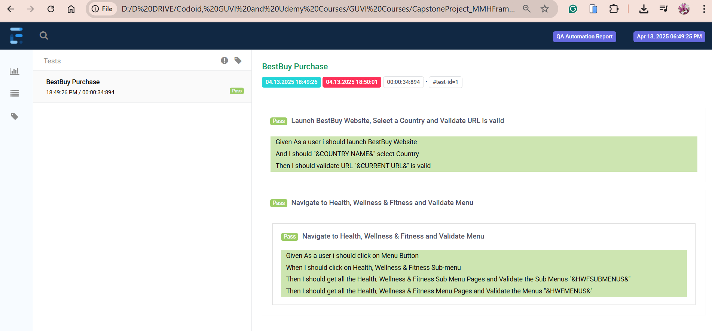

**Scenario Outline**: Navigate to Outdoor Living and Validate Menu

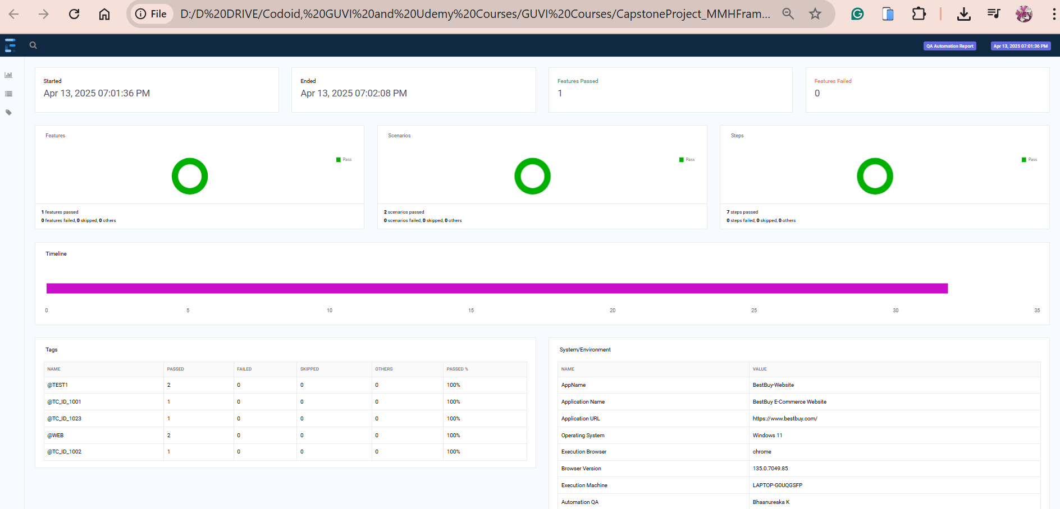

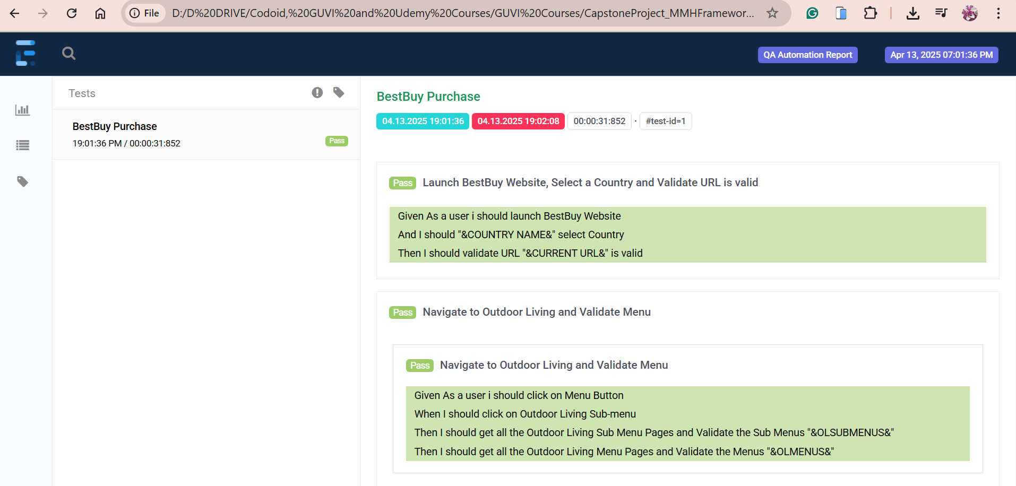

**Scenario Outline**: Navigate to Toys, Games & Collectibles and Validate Menu

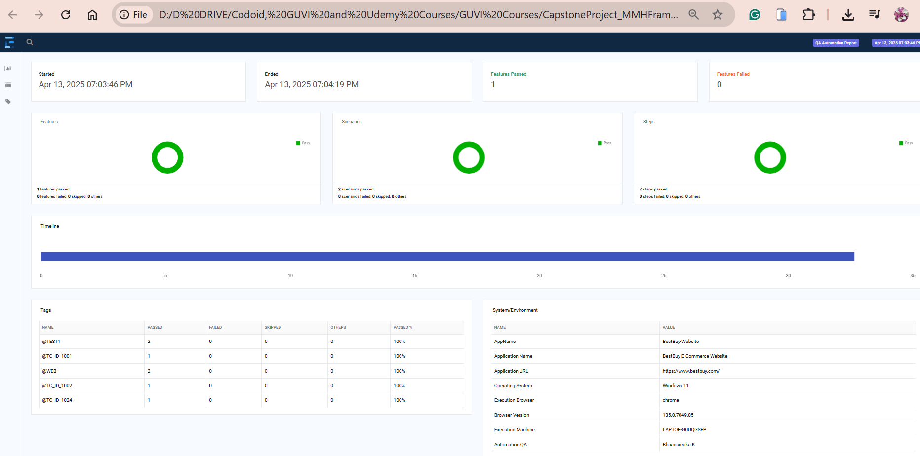

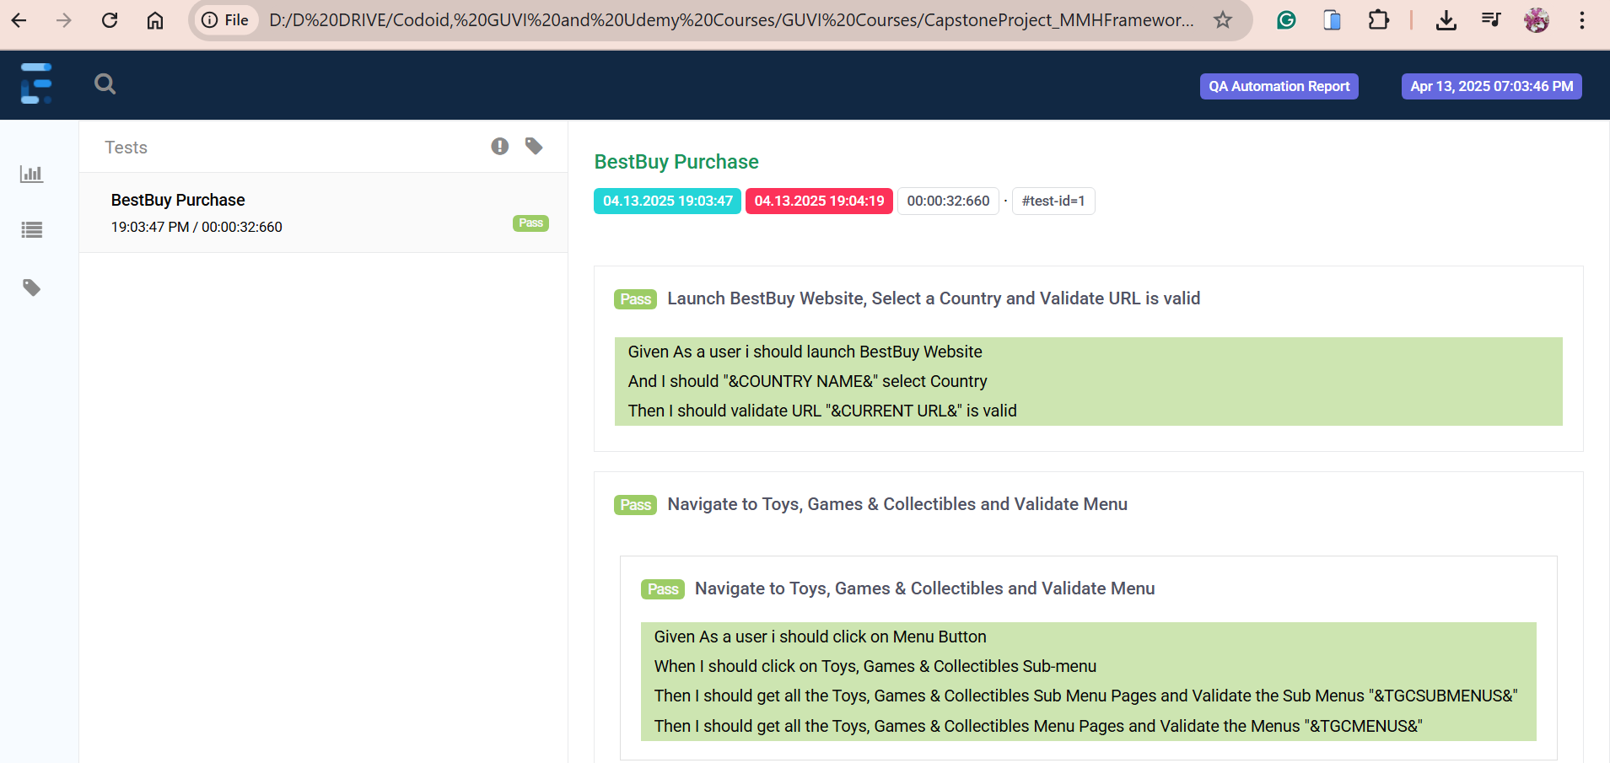

**Scenario Outline**: Navigate to Electric Transportation and Validate Menu

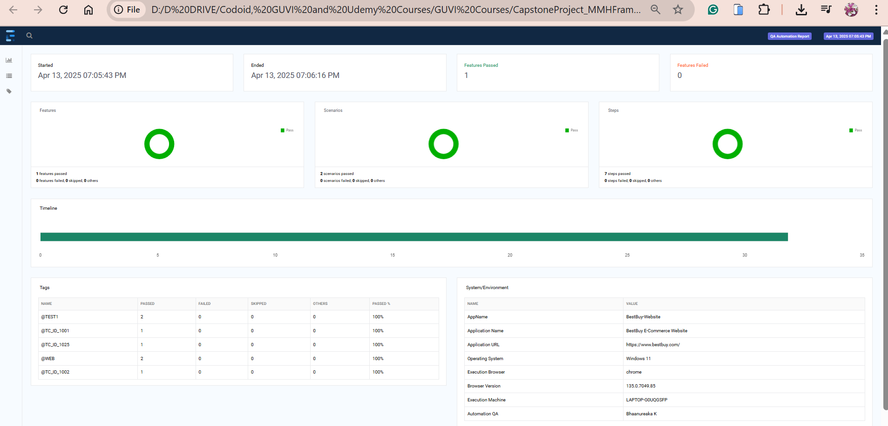

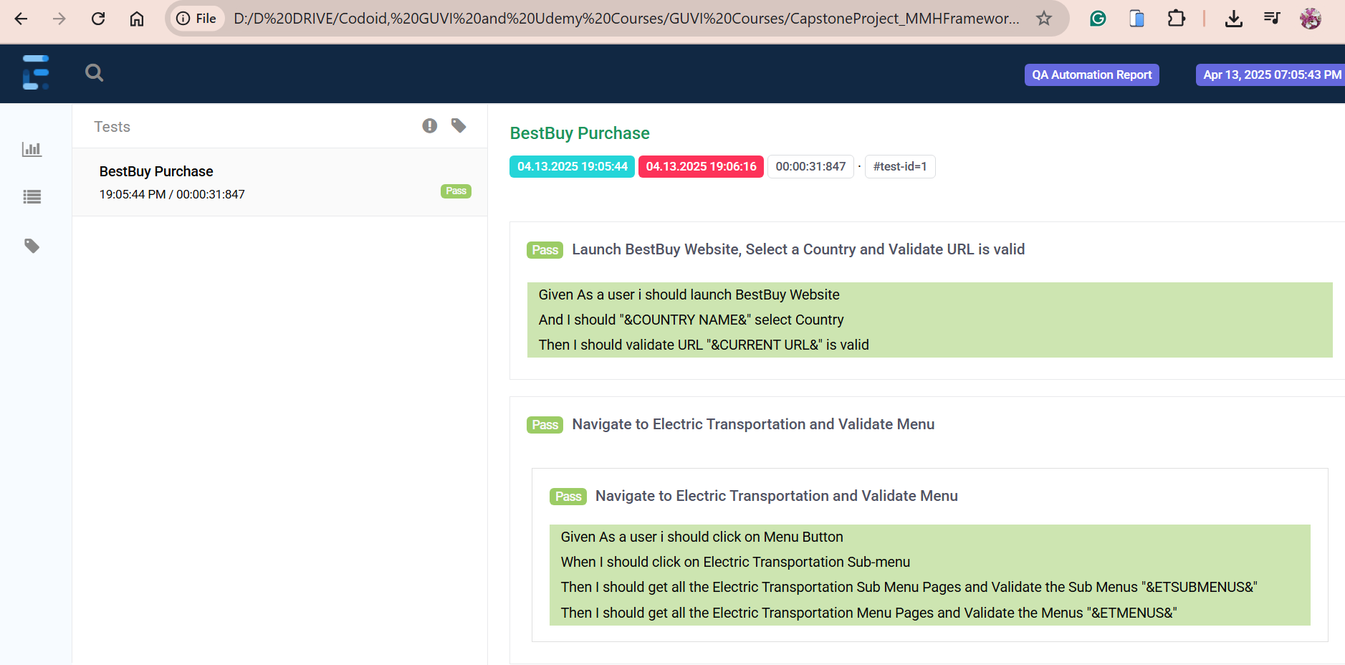

**Scenario Outline**: Navigate to New & Featured and Validate Menu

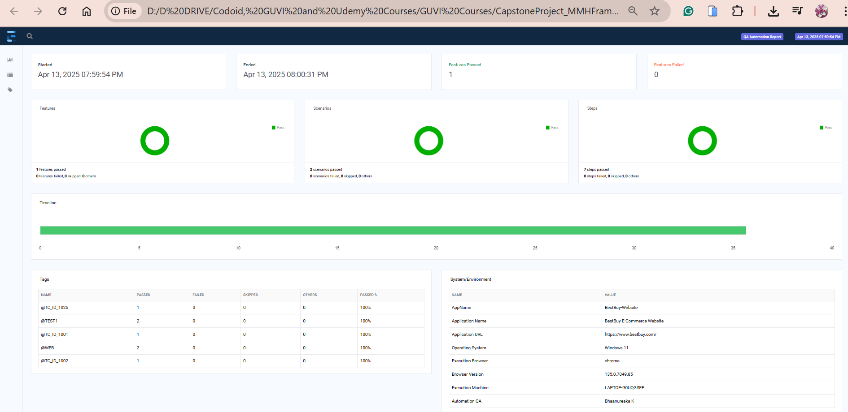

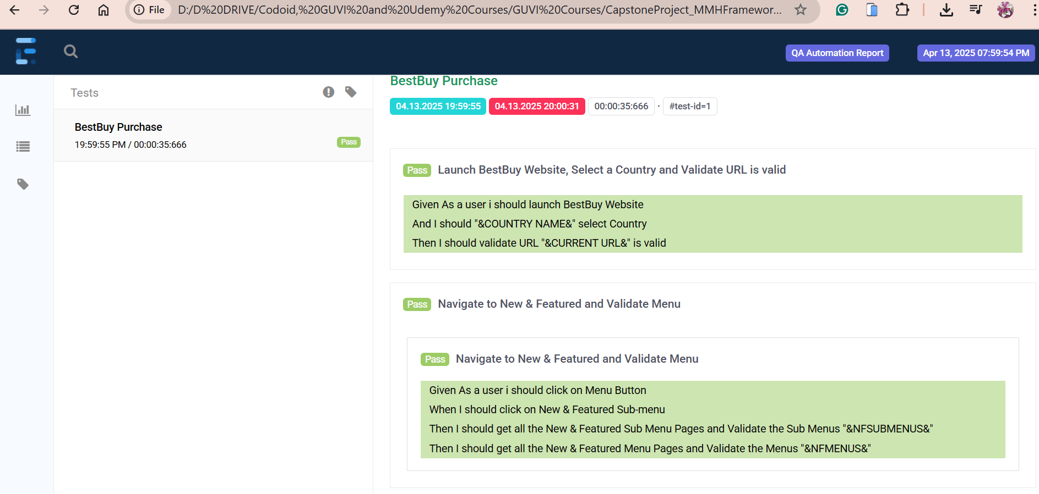

**Scenario Outline**: Navigate to Footer Support Links

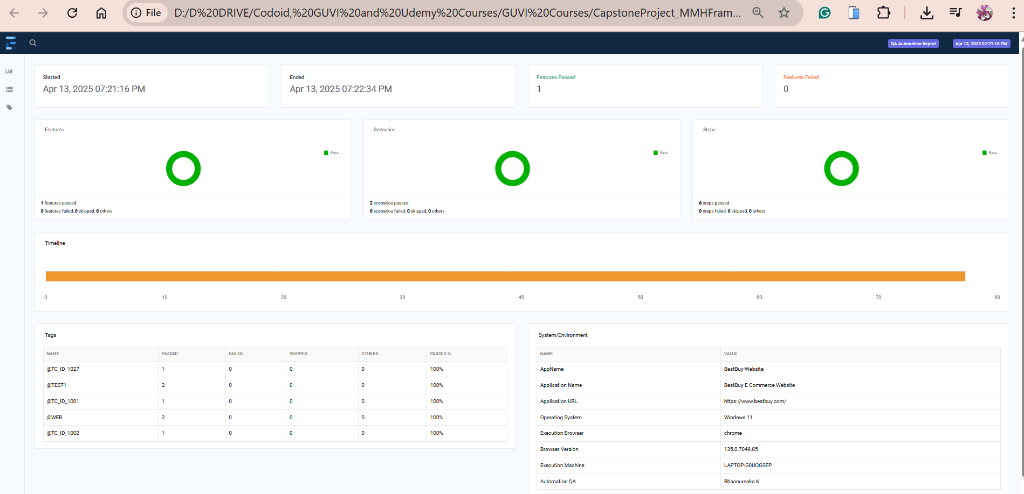

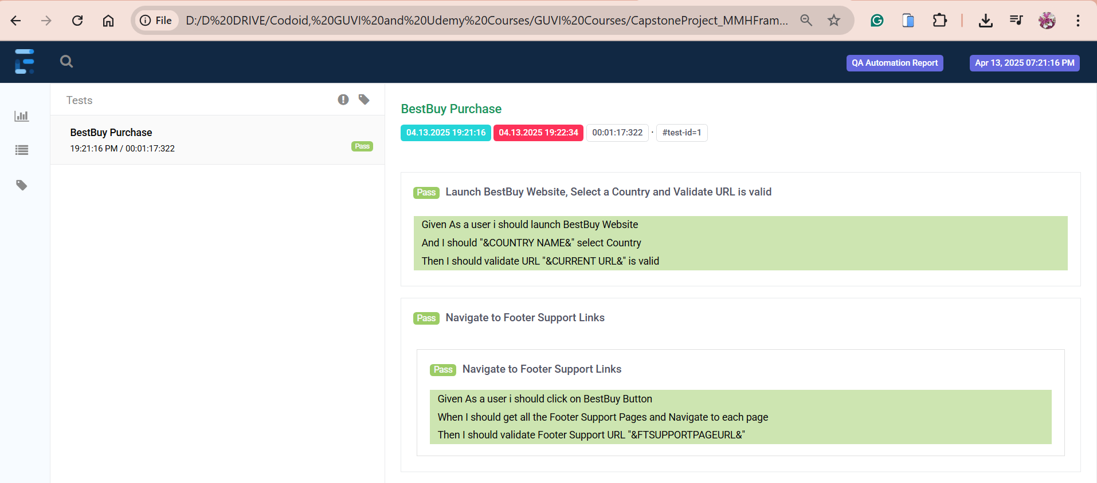

**Scenario Outline**: Navigate to All Footer Links

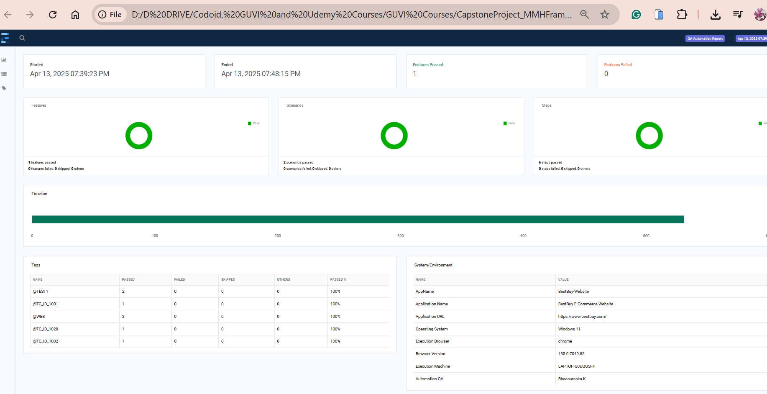

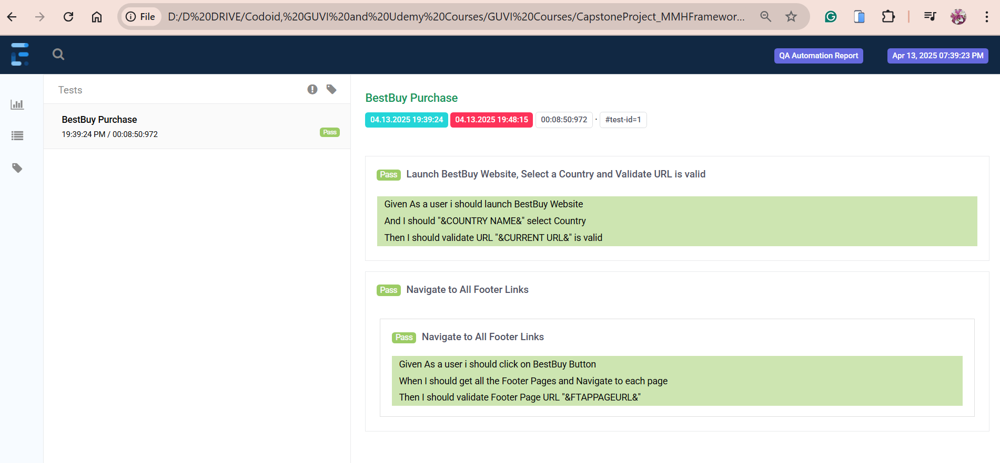

**Scenario Outline**: Navigate to Footer T&C Links

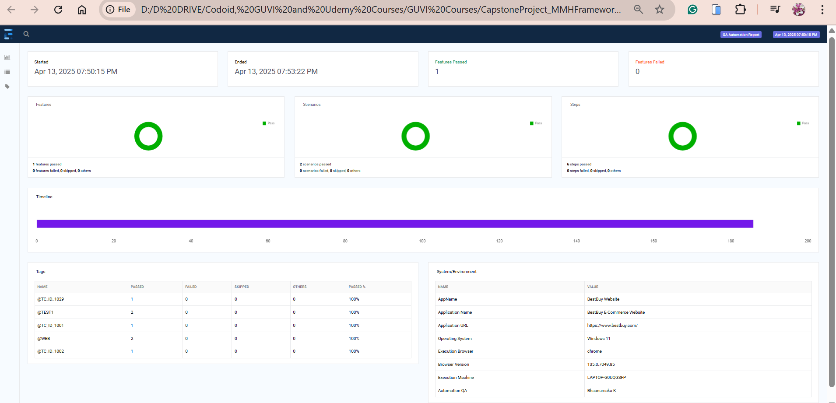

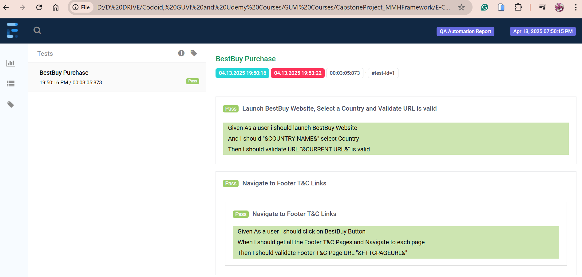

**Scenario Outline**: Search a Product from search bar and add it to Cart

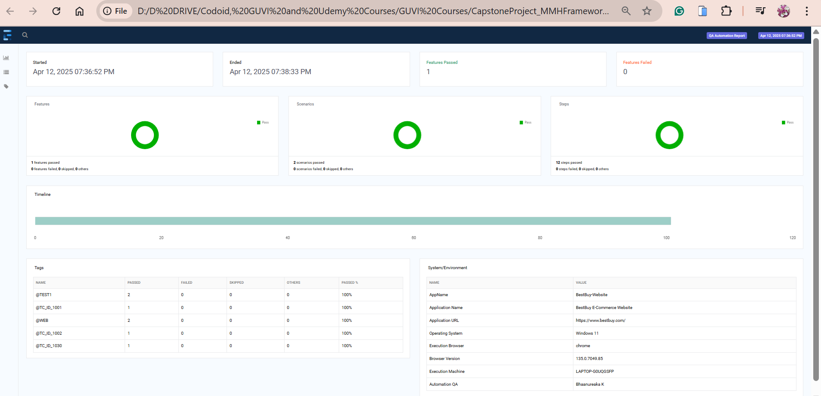

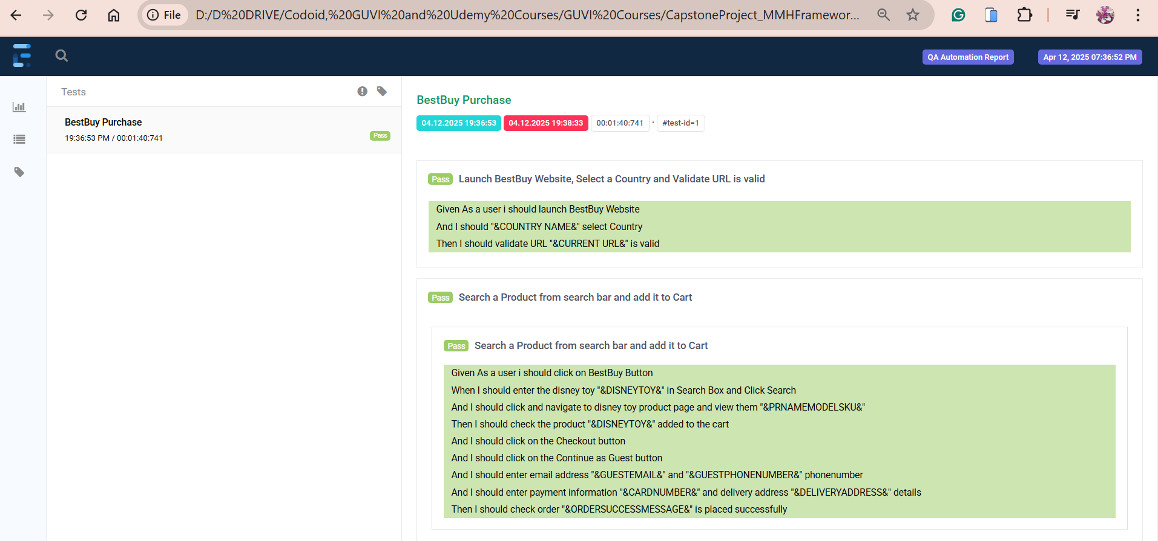

**Scenario Outline**: Navigate to Shop by Department and add a Product to Cart from Toys, Games & Collectibles and Brand Barbie

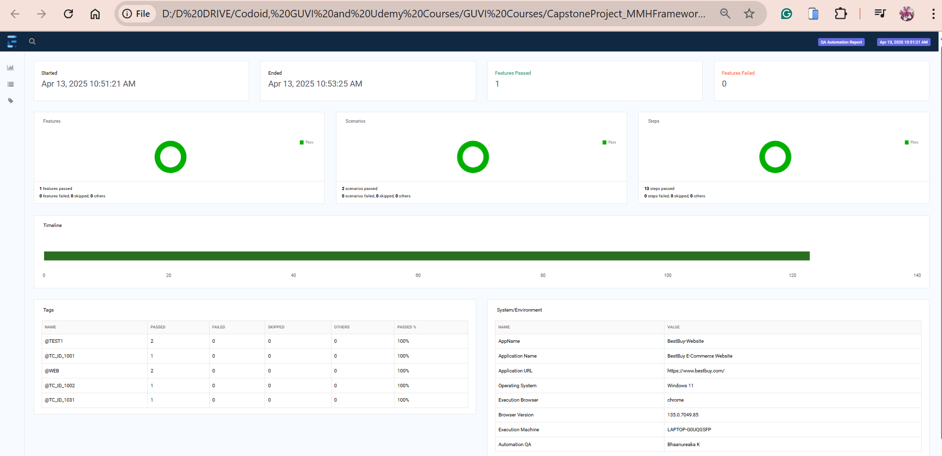

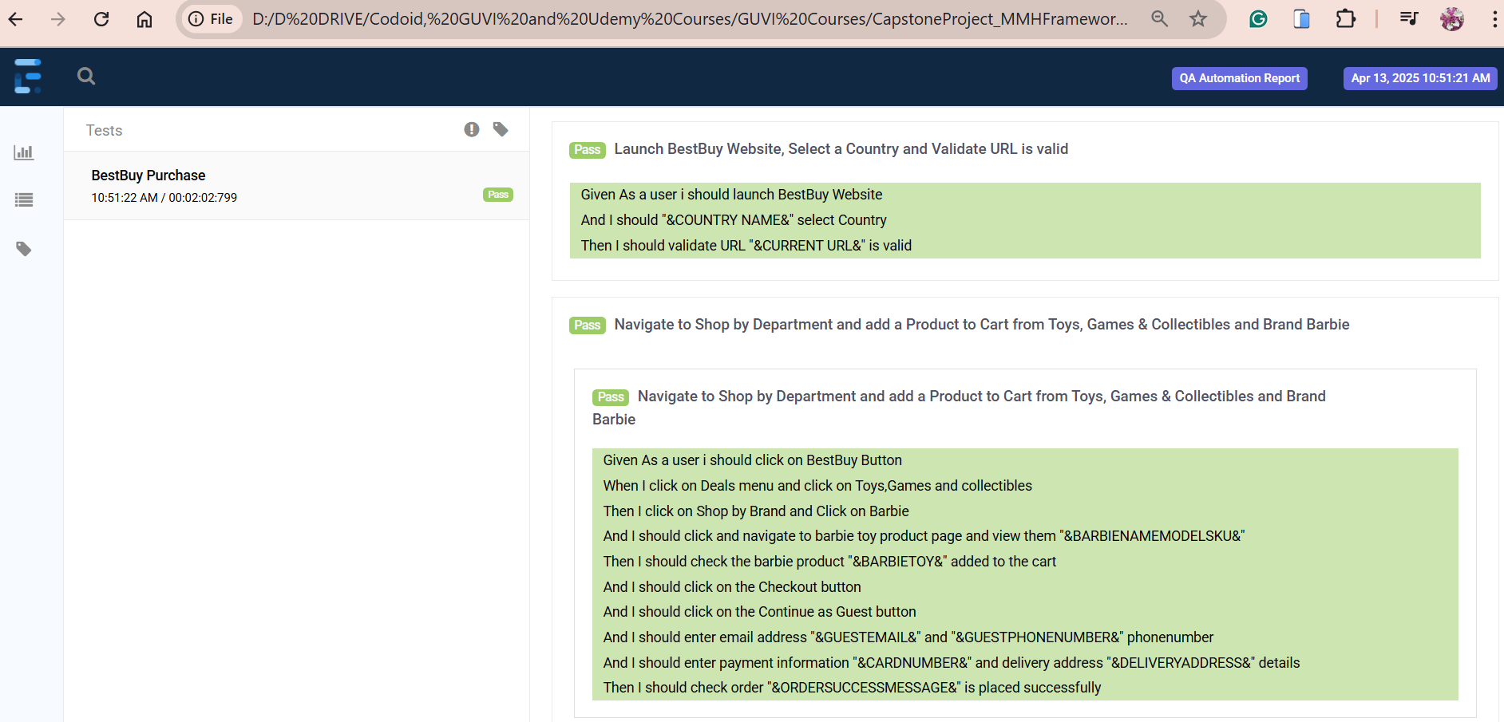

**Scenario Outline**: Navigate to Select By Brand and add a Product to Cart from Toys, Games & Collectibles and Brand Barbie

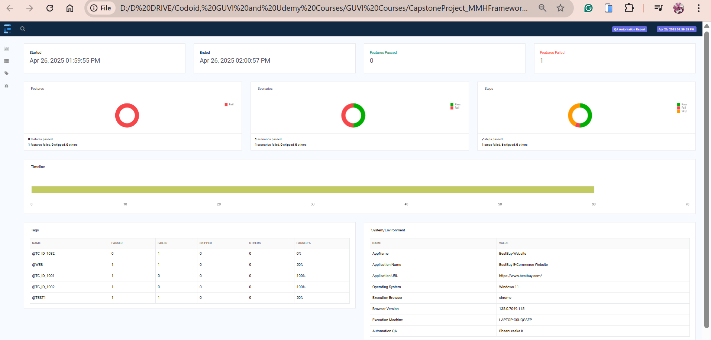

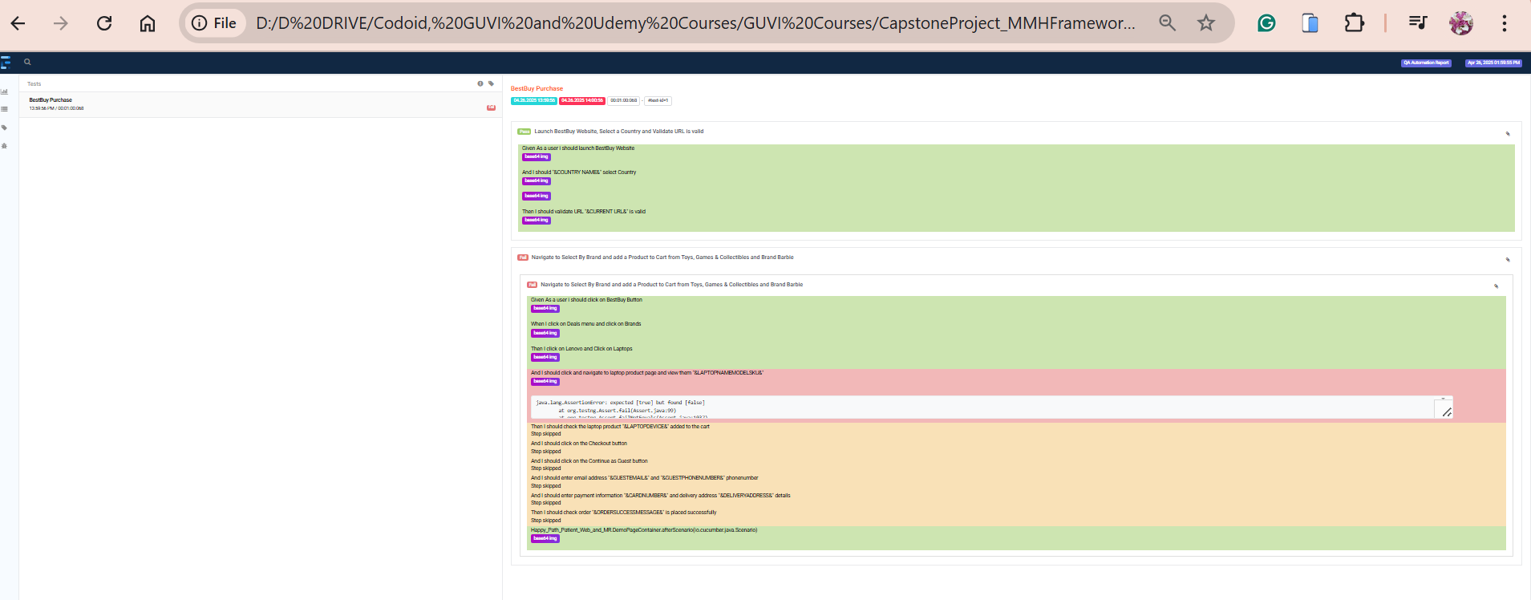

**Scenario Outline**: Search a Wrong Product from search bar and verify message

